LESSON DEVELOPMENT THREE

PLANE SHAPES – A CIRCLE
ARC AND SECTOR

STAGE/TIME | TEACHER’S ACTIVITIES | LEARNER'S ACTIVITIES – MIND/HANDS ON | LEARNING POINTS
Step 1  Introduction  (5 minutes) | INTRODUCTORY ACTIVITIES –  Asks the pupils to draw with a diameter, radius, chord and segment. | HANDS ON ACTIVITIES  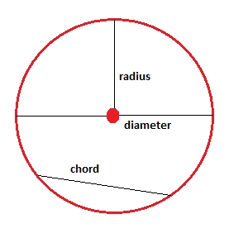 | Linking the Previous knowledge to the new lesson
Step 2  Development  (5 minutes)  Grouping | 1. Groups the learners into four groups – A, B, C, and D.  2. Guide the learners to choose a leader and secretary for your group.  3. Gives each group learning materials – cardboard, scissor and drawing materials. | 1. Belong to a group.  2. Choose their leader and secretary.  3. Received learning materials for their group. | Learner’s group, leader and secretary confirmed.
Step 3  Development  (5 minutes) | GENERAL ACTIVITIES – INSTRUCTIONS  1. Draw 2 circles on a cardboard.  2. Cut out the 2 circles.  3. Fold one of the circles into two equal parts. Don’t cut.  4. Fold the two semi circles.  5. The circle is divided into 4, cut out one part.  6. Trace the line on the second circle not cut.  7. Compare your results with this chart. | HANDS ON ACTIVITIES  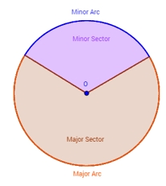 | Part of circle – a arc and sector (minor and major)
Step 4  Development  (10 minutes) | GROUPS ACTIVITIES – INSTRUCTIONS  1. Differentiate between minor and major sector.  2. Differentiate between minor and major arc. | GROUPS WORK  1. A sector is a portion between two radii (radii plural of radius). The small part is called a minor sector while the large part is called major sector. | Identification of arc and sector.
Step 5  Development  (10 minutes) | Asks each group to present their results/solutions so that you can compare responses with those in other groups. | Presentation  2. An arc is the distance between points on the circumference. The small part is called minor arc while the large part is called major arc. | Group Presentation
Step 6  Conclusion  (5 minutes) | To conclude the lesson, the teacher revises the entire lesson and ask the key questions.  SUMMARY – as in the presentation. | The learners listen, ask and answer questions. | Lesson Evaluation and Conclusion

Reference book – New Method Mathematics Book 5.

