LESSON DEVELOPMENT FOUR
LESSON EVALUATION
Use the circle below to answer the questions.
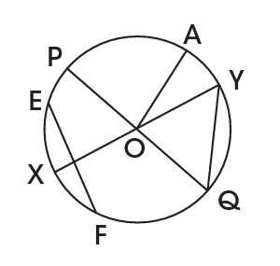

1. Measure radius OA. Copy and complete: OA = _______
2. Name four other radii. (Radii is the plural of radius.)
3. Copy and complete: OY = _______, OQ = _______, OY = _______
4. Are all the radii of the same length? YES/NO
5. Measure the diameter POQ.
6. Name another diameter and find its length.
7. Compare the length of a diameter with the length of a radius. What do you observe?
Copy and complete these statements.
8. The length of a diameter is _______ the length of a radius.
9. The length of a radius is _______ that of a diameter.
10. Measure EF and QY. Record their lengths.
11. Compare the lengths of EF and QY with the length of POQ and XOY respectively. What do you observe?
REFERENCE – NEW METHOD MATHEMATICS BOOK 5.
PAGE – 233 (EXERCISE 1).

