LESSON DEVELOPMENT ONE

SHAPE CONSTRUCTION

STAGE/TIME | TEACHER’S ACTIVITIES | LEARNER'S ACTIVITIES – MIND/HANDS ON | LEARNING POINTS
Step 1  Introduction  (5 minutes) | INTRODUCTORY ACTIVITIES –  Asks pupils to name the different shapes that they know about.  Tells them that some of these are flat and some have depth and are solid shapes. We are going to examine solid shapes. | MIND ON ACTIVITIES  Different shapes –  1. Triangle  2. Circle  3. Square and rectangle  4. Cube and cuboid  5. Cylinder, etc. | Linking the Previous knowledge to the new lesson
Step 2  Development  (5 minutes)  Grouping | 1. Groups the learners into four groups – A, B, C, and D.  2. Guide the learners to choose a leader and secretary for your group.  3. Gives each group learning materials – empty matchboxes, plastic funnels, cubes of sugar, sheets of cardboard paper, scissors, glue/masking tape, pencils and markers. Various geometric shapes | 1. Belong to a group.  2. Choose their leader and secretary.  3. Received learning materials for their group. | Learner’s group, leader and secretary confirmed.
Step 3  Development  (5 minutes) | 1. Asks them to look around the classroom without moving about and identify some solid shapes like the ones they have mentioned. (capture their answers on the board).  2. Draws some shapes on the board and asks the pupils to guess what the object is.  3. Explains to them that objects we see around have different shapes.  4. Tells them that we will be learning about shape construction in today’s lesson. | 1. The doors and window, waste bin, and many items in the classroom shopping corners.  House, car and computer.  3. Listen to the teacher’s explanation. | Identification of solid shapes
Step 4  Development  (10 minutes) | GROUP ACTIVITIES – INSTRUCTIONS  1. Displays the various geometric shapes on the board. Points at each shape and asks pupils to identify them.  2. Ensures they can identify all the shapes by giving them support in form of clues and guidance.  2. Asks pupils to work in group and construct any of the following solid shapes using cardboard paper, sellotape and scissors (these can be shared).  3. Ask each pupil to name their solid shape and display it in the classroom. | HANDS ON ACTIVITIES  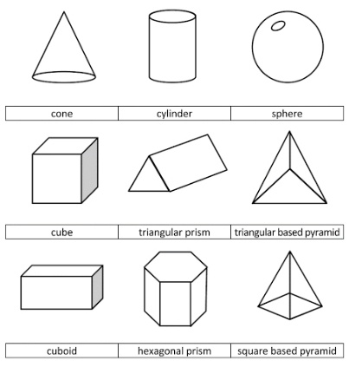 | Construction of shapes
Step 5  Development  (15 minutes) | Asks each group to present their results/solutions so that you can compare responses with those in other groups. | Presentation | Group Presentation
Step 6  Conclusion  (5 minutes) | To conclude the lesson, the teacher revises the entire lesson and ask the key questions.  SUMMARY – When we make shapes of different objects using paper, wood or metal, we are said to be doing shape construction.  KEY QUESTIONS – what is shape construction with paper?  ASSIGNMENT – Identify and escribe the contents of this shape. | The learners listen, ask and answer questions.  Shape construction is the making of different shapes of objects such as cylinder, cone, funnel, matchbox, etc. using paper or cardboard.  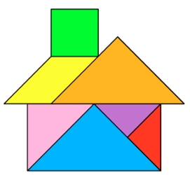 | Lesson Evaluation and Conclusion

Reference book – Primary 4 Basic Science & Technology

