LESSON DEVELOPMENT TWO

MATERIALS AND CUTTING TOOLS USED IN SHAPE CONSTRUCTION

STAGE/TIME | TEACHER’S ACTIVITIES | LEARNER'S ACTIVITIES – MIND/HANDS ON | LEARNING POINTS
Step 1  Introduction  (5 minutes) | INTRODUCTORY ACTIVITIES –  Asks pupils to identify this shape.  Tells them to make a list of materials and cutting tools used in constructing this shape. | 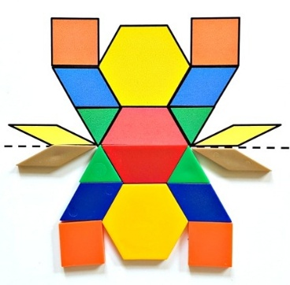  MIND ON ACTIVITIES  This sis a spider.  Materials and cutting tools –  Cartoon, color cardboard, ruler, pencil, gum or glue, scissor or blade. | Linking the Previous knowledge to the new lesson
Step 2  Development  (5 minutes)  Grouping | 1. Groups the learners into four groups – A, B, C, and D.  2. Guide the learners to choose a leader and secretary for your group.  3. Gives each group learning materials – materials and cutting used in shape construction. Sample of shape construction – as in step 1. Chart of 2 dimensional shapes. | 1. Belong to a group.  2. Choose their leader and secretary.  3. Received learning materials for their group. | Learner’s group, leader and secretary confirmed.
Step 3  Development  (5 minutes) | Asks pupils to examine the spider constructed. |  | Identification of solid shapes
Step 4  Development  (10 minutes) | GROUP ACTIVITIES – GUIDED INSTRUCTIONS  1. Asks the groups to construct a spider with the materials and cutting tools given to them.  2. Asks them to identify each shapes that made of the construed spider by comparing with the chart. | 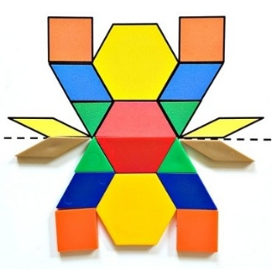  HANDS ON ACTIVITIES  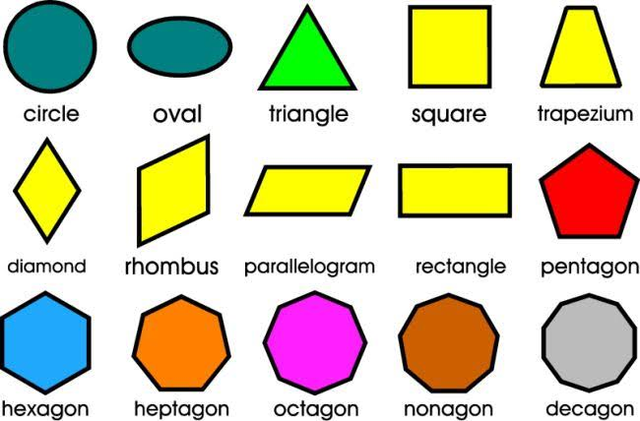 | Construction of shapes
Step 5  Development  (15 minutes) | Asks each group to present their results/solutions so that you can compare responses with those in other groups. | Presentation | Group Presentation
Step 6  Conclusion  (5 minutes) | To conclude the lesson, the teacher revises the entire lesson and ask the key questions.  SUMMARY – Materials and cutting tools used for shape construction – cartoon, color cardboard, paper, scissors, glue/masking tape, pencils and markers.  KEY QUESTIONS (ASSIGNMENT) – Construct the shape in the chart. | The learners listen, ask and answer questions.  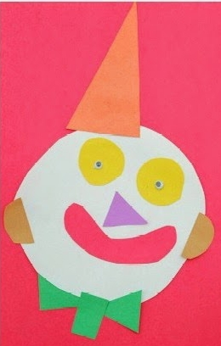 | Lesson Evaluation and Conclusion

Reference book – Primary 4 Basic Science & Technology

