LESSON DEVELOPMENT THREE

SHAPE CONSTRUCTION METHODS – FOLDING AND BENDING

STAGE/TIME | TEACHER’S ACTIVITIES | LEARNER'S ACTIVITIES – MIND/HANDS ON | LEARNING POINTS
Step 1  Introduction  (5 minutes) | INTRODUCTORY ACTIVITIES –  Asks pupils to identify the following shapes. | MIND ON ACTIVITIES  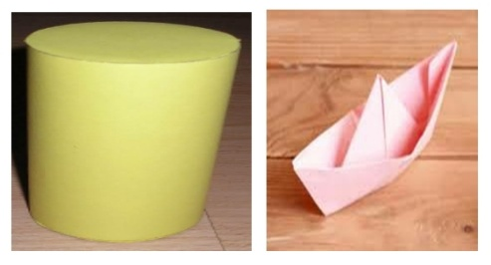  A cylinder  A boat | Linking the Previous knowledge to the new lesson
Step 2  Development  (5 minutes)  Grouping | 1. Groups the learners into four groups – A, B, C, and D.  2. Guide the learners to choose a leader and secretary for your group.  3. Gives each group learning materials – Sample of shape construction (fold and bend) and materials needed for shape construction. | 1. Belong to a group.  2. Choose their leader and secretary.  3. Received learning materials for their group. | Learner’s group, leader and secretary confirmed.
Step 3  Development  (5 minutes) | Asks pupils to describe how these shapes are constructed.  After description, tells them that folding and bending are methods of shape construction. | The cylinder shape is constructed by bending while the boat is constructed by folding. | Shape construction methods – folding and bending
Step 4  Development  (10 minutes) | GROUP ACTIVITIES – GUIDED INSTRUCTIONS  Guides and asks pupils to construct both cylinder and boat. | HANDS ON ACTIVITIES | Construction of cylinder and boat
Step 5  Development  (15 minutes) | Asks each group to present their results/solutions so that you can compare responses with those in other groups. | Presentation | Group Presentation
Step 6  Conclusion  (5 minutes) | To conclude the lesson, the teacher revises the entire lesson and ask the key questions.  SUMMARY – Shapes can be constructed using the following methods – folding and bending methods. Other methods are cutting and joining.  The various materials used in shape construction will determine the type of method that will be used. | The learners listen, ask and answer questions.  KEY QUESTIONS (ASSIGNMENT) – List 10 shapes that can be constructed by folding and bending methods.  1. Cube 6. Cone  2. Cuboid 7. Bird  3. Cylinder 8. Car  4. Boat 9. House  5. Funnel 10. Touch light | Lesson Evaluation and Conclusion

Reference book – Primary 4 Basic Science & Technology

