LESSON DEVELOPMENT TWO

SCALE DRAWING – A FOOTBALL FIELD

STAGE/TIME | TEACHER’S ACTIVITIES | LEARNER'S ACTIVITIES – MIND/HANDS ON | LEARNING POINTS
Step 1  Introduction  (5 minutes) | INTRODUCTORY ACTIVITIES –  Takes all groups to the field to measure the length and width of the field.  Supervises their activities and ensure proper and accurate measurements. | 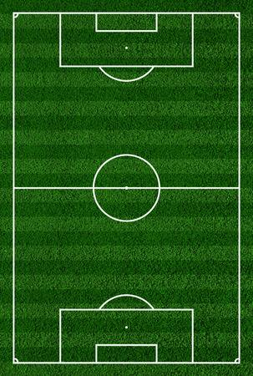  HANDS ON ACTIVITIES | Linking the Previous knowledge to the new lesson
Step 2  Development  (5 minutes)  Grouping | 1. Groups the learners into four groups – A, B, C, and D.  2. Guide the learners to choose a leader and secretary for your group.  3. Gives each group learning materials – measuring tape, pencils cleaners and cardboard. | 1. Belong to a group.  2. Choose their leader and secretary.  3. Received learning materials for their group. | Learner’s group, leader and secretary confirmed.
Step 3  Development  (10 minutes) | GROUPS ACTIVITIES – INSTRUCTIONS  Choose suitable scale for football field (reduction) and draw. | GROUPS WORK | Scale Drawing
Step 4  Development  (15 minutes) | Asks each group to present their results/solutions so that you can compare responses with those in other groups. | Presentation | Group Presentation
Step 5  Conclusion  (5 minutes) | To conclude the lesson, the teacher revises the entire lesson and ask the key questions.  SUMMARY – Sometimes it is not practical or positive to draw a real object to its actual size.  For example, when architects design buildings, they do not produce a real-life size drawing of the building.  To do this, a scale drawing is produced to replace the real size of what we want to do. | The learners listen, ask and answer questions. | Lesson Evaluation and Conclusion

Reference book – New Method Mathematics Book 6.

