LESSON DEVELOPMENT ONE

INTRODUCTION TO FRICTION

STAGE/TIME | TEACHER’S ACTIVITIES | LEARNER'S ACTIVITIES – MIND/HANDS ON | LEARNING POINTS
Step 1  Introduction – Introductory Activities  (5 minutes) | Asks pupils to rub the palms of your hands together very firmly.  How do they feel?  Wet your palms and again rub them together while they are wet. What do you observe? | 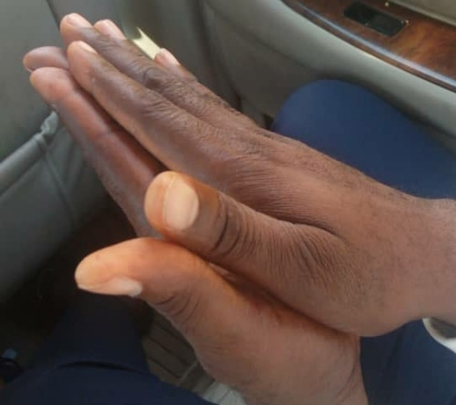 | Linking the Previous knowledge to the new lesson
Step 2  Development  (5 minutes)  Grouping | 1. Groups the learners into four groups – A, B, C, and D.  2. Guide the learners to choose a leader and secretary for your group.  3. Gives each group learning materials – smooth and rough surface – plastic, hard paper, plank, sandpaper, etc. | 1. Belong to a group.  2. Choose their leader and secretary.  3. Received learning materials for their group. | Learner’s group, leader and secretary confirmed.
Step 3  Development – Groups Activities  (10 minutes) | Asks the groups to their hand against the smooth and rough objects. What do you observe?  Asks them to describe the surface of smooth and rough objects.  Tells them to rub –  1. Smooth and smooth,  2. Smooth and rough, and  3. Rough and rough together.  What do you think is preventing the free rubbing. | Activities and observations.  Description of both smooth and rough objects.  Activities and explanations. | Smooth and rough surface
Step 4  Development – Groups Presentation  (10 minutes) | Asks each group to present their results/solutions so that you can compare responses with those in other groups. | Presentation – Call on any member of at least two pairs in each to make presentation to the class. | Group Presentation
Step 5  Conclusion  (10 minutes) | To conclude the lesson, the teacher revises the entire lesson and ask the key questions.  SUMMARY – Where you rub smooth and smooth, smooth and rough, rough and rough surface together, you will experience free, easy and hard flow or movement.  Free movement means no obstacles. Easy movement means there is little obstacles while hard movement means there is a force preventing movement.  The force is called friction. | The learners listen, ask and answer questions.  KEY QUESTIONS –  What is friction?  Friction is the force that prevents free or smooth movement. | Lesson Evaluation and Conclusion

Reference book – Primary 5 Basic Science & Technology

