LESSON DEVELOPMENT FOUR

LINES OF SYMMETRY

STAGE/TIME | TEACHER’S ACTIVITIES | LEARNER'S ACTIVITIES – MIND/HANDS ON | LEARNING POINTS
Step 1  Introduction – Introductory Activities  (5 minutes) | Gives pupils a plain paper and asks them to fold the paper into 2 equal parts.  Tells them to draw a line with ruler on folded paper.  Asks them, how many times can the paper can be fold equally? | Expected response – 2 or 4 times | Linki the Previous knowledge to the new lesson
Step 2  Development  (5 minutes)  Grouping | 1. Groups the learners into four groups – A, B, C, and D.  2. Guide the learners to choose a leader and secretary for your group.  3. Gives each group learning materials – plain papers, mathematical sets with long rulers. Sample/chart of 2/3 dimensional shapes. | 1. Belong to a group.  2. Choose their leader and secretary.  3. Received learning materials for their group. | Learner’s group, leader and secretary confirmed.
Step 3  Development – Groups Activities  (5 minutes) | Tells the pupils that the lines are called lines of symmetry. Lines of symmetry divide a shape into equal parts.  When a shape is divided equally, both parts must be like.  Asks pupils – what shape is the plain paper? How many lines of symmetry in a rectangle? | The shape is a rectangle. It has 2 or 4 lines of symmetry (Expected Answer).  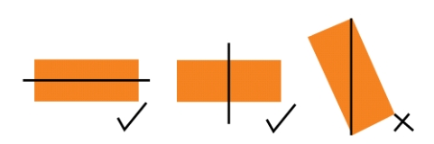  Lets the pupils know that a rectangle has 2 lines of symmetry. | Number of lines of symmetry in a rectangle.
Step 4  Development – Groups Activities  (10 minutes) | GUIDED INSTRUCTIONS  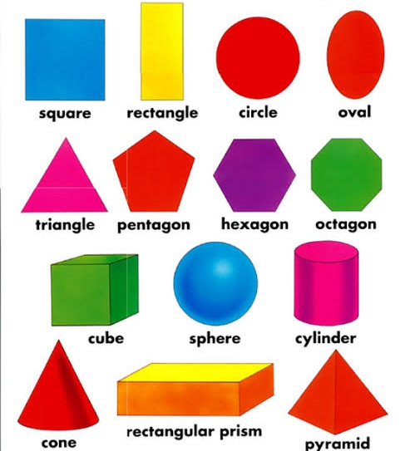  Find the number of lines of symmetry in the following shapes. | Shapes/Lines of symmetry  Square  Rectangle, 2 lines  Circle  Oval  Triangle,…. | Lines of symmetry
Step 5  Development – Presentation  (10 minutes) | Asks each group to present their results/solutions so that you can compare responses with those in other groups. | Presentation – Call on any member of at least two pairs in each to make presentation to the class. | Group Presentation
Step 7  Conclusion  (5 minutes) | To conclude the lesson, the teacher revises the entire lesson and ask the key questions.  SUMMARY  Lines of symmetry divide a shape into equal parts.  When a shape is divided equally, both parts must be like. | The learners listen, ask and answer questions.  KEY QUESTIONS - Find if the a to z can be divided into equal parts and how times?  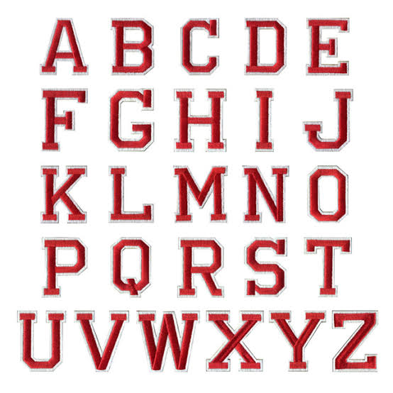 | Lesson Evaluation and Conclusion

Reference book – New Method Mathematics Book 6.
Instructional Materials

