LESSON DEVELOPMENT THREE

PROPERTIES OF CUBE AND CUBOID

STAGE/TIME | TEACHER’S ACTIVITIES | LEARNER'S ACTIVITIES – MIND/HANDS ON | LEARNING POINTS
Step 1  Introduction – Introductory Activities  (5 minutes) | Asks pupils to differentiate between square and rectangle. | Square has all lines and angles are equal.  Rectangle has 2 opposite lines are equal. Also, all angles are equal. | Linking the Previous knowledge to the new lesson
Step 2  Development  (5 minutes)  Grouping | 1. Groups the learners into four groups – A, B, C, and D.  2. Guide the learners to choose a leader and secretary for your group.  3. Gives each group learning materials – sample of cube and cuboid. Charts of cube and cuboid. | 1. Belong to a group.  2. Choose their leader and secretary.  3. Received learning materials for their group. | Learner’s group, leader and secretary confirmed.
Step 3  Development – Groups Activities  (5 minutes) | Asks each group to –  1. Compare cube and cuboid with the ones on chart.  2. Identify the name of cube and cuboid with the one on chart. | 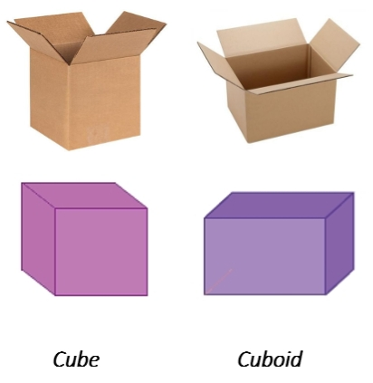 | Identification of cube and cuboid.
Step 4  Development – Groups Activities  (10 minutes) | GUIDED INSTRUCTIONS  Guides the groups to identify the faces, vertices and edges of cube and cuboid. Also asks,  1. There are _______ faces.  2. There are _______ vertices.  3. There are _______ edges.  4. Cut out a face of cube and cuboid. What shape do you observe? | Cube  Number of faces _______  Number of vertices _______  Number of edges _______  Cuboid  Number of faces _______  Number of vertices _______  Number of edges _______  Observations – square and rectangle | Properties of cube and cuboid.
Step 5  Development – Presentation  (10 minutes) | Asks each group to present their results/solutions so that you can compare responses with those in other groups. | Presentation – Call on any member of at least two pairs in each to make presentation to the class. | Group Presentation
Step 7  Conclusion  (5 minutes) | To conclude the lesson, the teacher revises the entire lesson and ask the key questions.  SUMMARY  Cube is a 3-dimensional solid object bounded by six square faces or sides. It has 6 faces, 12 edges, and 8 vertices.  Cuboid is a 3-dimensional shade bounded by six faces (only rectangle or both rectangle and square). It has 6 faces, 12 edges, and 8 vertices. | The learners listen, ask and answer questions.  KEY QUESTIONS  Differentiate between between cube and cuboid.  ASSIGNMENT  Construct a cube and cuboid.  Mention 6 objects each for cube and cuboid that represent both shape. For example – Maggi cube or shoes package (cuboid). | Lesson Evaluation and Conclusion

Reference book – New Method Mathematics Book 6.
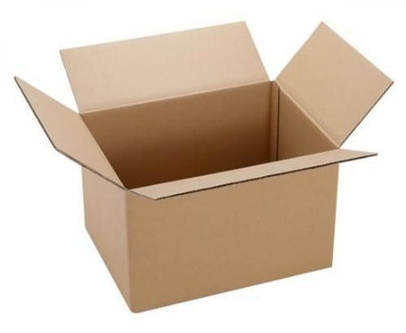
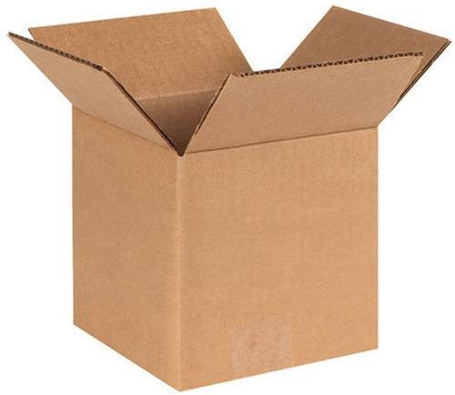
Instructional Materials
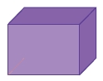
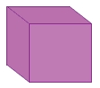

Cube Cuboid

