LESSON DEVELOPMENT ONE

PROPERTIES OF TRIANGLES

STAGE/TIME | TEACHER’S ACTIVITIES | LEARNER'S ACTIVITIES – MIND/HANDS ON | LEARNING POINTS
Step 1  Introduction – Introductory Activities  (5 minutes) | 1. Draw a line.  2. Draw another line from the starting or end of the first line. 3. How many lines have you drawn?  4. Draw another line to join the first and second lines together.  5. How many lines and angles altogether?  6. What shape do you observe?  7. What shape is this?  8. Triangle has many corners?  Note – Lets pupils know that the 3 corners of triangle is called vertices (where 2 lines meet). | 1.  2.  3. 2 lines.  4.  5. 3 lines and 3 angles.  6. Observation.  7. Triangle.  8. 3 corners. | Linking the Previous knowledge to the new lesson
Step 2  Development  (5 minutes)  Grouping | 1. Groups the learners into four groups – A, B, C, and D.  2. Guide the learners to choose a leader and secretary for your group.  3. Gives each group learning materials – chart and sample of triangles, mathematical set and a long rulers. | 1. Belong to a group.  2. Choose their leader and secretary.  3. Received learning materials for their group. | Learner’s group, leader and secretary confirmed.
Step 3  Development  (5 minutes) | TRIANGLE  1. Name the 3 corners A, B and C.  Teacher’s comments – The triangle is called triangle ABC.  If the side between A and B is called AB.  2. Side between A and C, B and C are called _____________.  The angle at:  If corner A is called angle A or angle BAC, what is corner B and C? | 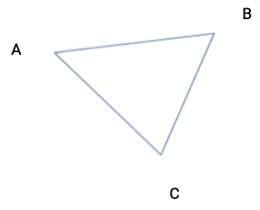  Listen to teacher’s comments.  2. Side between A and C is called AC.  Side between B and C is called BC.  3. Corner B is called angle B or angle ABC.  Corner C is called angle C or angle ACB. | Properties of Triangle
Step 4  Development – Groups Activities  (10 minutes) | TYPES OF TRIANGLES  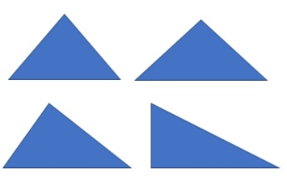  1. Study the chart.  2. Name the sides of each triangle ABC.  3. Measure AB, AC and BC of each triangle.  4. Measure angle A, B and C in all triangles.  5. Record your measurements.  6. What is your observations. | 3 and 4. First triangle –  AB _______, ABC _______  AC _______, BAC _______  BC _______, ACB _______  Second triangle –  AB _______, ABC _______  AC _______, BAC _______  BC _______, ACB _______  Third triangle –  AB _______, ABC _______  AC _______, BAC _______  BC _______, ACB _______  Fourth triangle –  AB _______, ABC _______  AC _______, BAC _______  BC _______, ACB _______  5. Observations –  First triangle, all sides and angles are equal.  Second triangle, 2 of its sides and base angles are equal.  Third triangle, no equal sides and angles.  Fourth triangle has one of its angles to equal 90°. | Types of Triangle and their properties.
Step 5  Development – Presentation  (10 minutes) | Asks each group to present their results/solutions so that you can compare responses with those in other groups. | Presentation – Call on any member of at least two pairs in each to make presentation to the class. | Group Presentation
Step 7  Conclusion  (5 minutes) | To conclude the lesson, the teacher revises the entire lesson and ask the key questions.  SUMMARY  First triangle is called equilateral triangle.  Second triangle is called isosceles triangle.  While the third triangle is called scalene triangle.  The fourth triangle is a right - angle triangle. One of its angles is at 90°.  Lines of symmetry  Lines of symmetry are lines that divide a shape equally.  Draw isosceles, scalene and right angle triangles, find the number of lines of symmetry in these triangles. | The learners listen, ask and answer questions.  Assignment  1. What is a triangle?  2. How many types of triangle do we have?  3. Name them.  4. What are the properties or characteristics of each types of triangle?  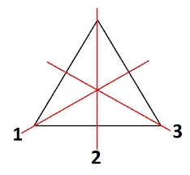 | Lesson Evaluation and Conclusion

Reference book – New Method Mathematics Book 4.

