LESSON DEVELOPMENT TWO

ARRANGE CONTAINERS BASED ON THEIR CAPABILITIES

STAGE/TIME | TEACHER’S ACTIVITIES | LEARNER'S ACTIVITIES – MIND/HANDS ON | LEARNING POINTS
Step 1  Introduction – Introductory Activities  (5 minutes) | Asks pupils –  Apart from water, what other things can we used these containers for. | 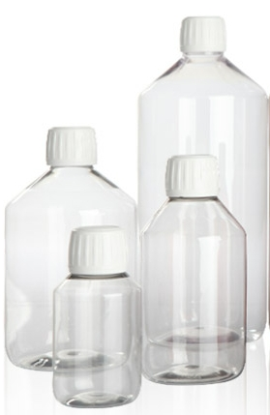 | Linking the Previous knowledge to the new lesson
Step 2  Development  (5 minutes)  Grouping | 1. Groups the learners into four groups – A, B, C, and D.  2. Guide the learners to choose a leader and secretary for your group.  3. Gives each group learning materials – four different sizes for each of spoons, cups, filling bottle, bottle water container, bucket, gallons, bucket of water. | 1. Belong to a group.  2. Choose their leader and secretary.  3. Received learning materials for their group. | Learner’s group, leader and secretary confirmed.
Step 3  Development – Groups Activities  (5 minutes) | Asks pupils to –  Identify the following  1. Spoons  2. Cups  3. Filling bottle (if available)  4. Bucket (if available)  5. Bottle water  6. Gallons (if available) | 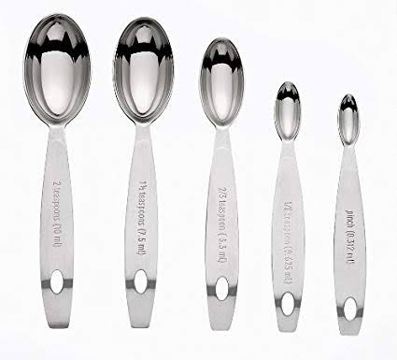  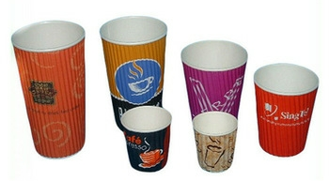 | Identification of different sizes of containers
Step 4  Development – Groups Activities and Presentation  (15 minutes) | Guides pupils to –  Arrange each of the following according to their sizes –  Spoons  Cups  Filling bottles  Bottles water  Gallon | 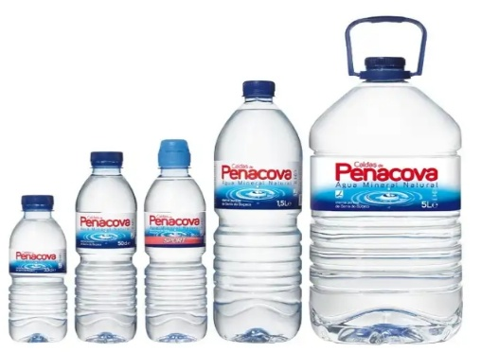 | Capacity of different containers
Step 5  Conclusion  (10 minutes) | To conclude the lesson, the teacher revises the entire lesson and ask the key questions.  SUMMARY  Different containers have different capabilities. Some are small. There are medium and bigger ones.  Small containers are spoons, cups, filling bottle, etc. The medium ones are gallon, bucket, etc. While drum and gallon, etc. are the bigger ones.  Container is used for holding or storing water, tea, etc. Capacity amount of liquid in a container. | The learners listen, ask and answer questions.  KEY QUESTIONS  1. _______ is used to hold water, tea, kerosene, etc.  (a) container  (b) capacity  (c) basket  2. _______ is the amount in a container.  (a) container  (b) capacity  (c) basket  3. _______ is used for taking liquid medicine (drug)  (a) spoon  (b) cup  (c) bucket | Lesson Evaluation and Co…………. nclusion

Reference book – New Method Mathematics Book 2.
Instructional Materials
