LESSON DEVELOPMENT THREE

COMPARING CAPACITY

STAGE/TIME | TEACHER’S ACTIVITIES | LEARNER'S ACTIVITIES – MIND/HANDS ON | LEARNING POINTS
Step 1  Introduction – Introductory Activities  (5 minutes) | Marks the containers A, B C and D, and lets pupils compare one with another. | 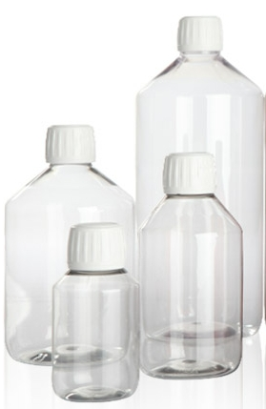 | Linking the Previous knowledge to the new lesson
Step 2  Development  (5 minutes)  Grouping | 1. Groups the learners into four groups – A, B, C, and D.  2. Guide the learners to choose a leader and secretary for your group.  3. Gives each group learning materials – spoon, cup, filling bottle, bottle water container, bucket, gallon, bucket of water. | 1. Belong to a group.  2. Choose their leader and secretary.  3. Received learning materials for their group. | Learner’s group, leader and secretary confirmed.
Step 3  Development – Groups Activities  (5 minutes) | Asks pupils to –  Pour water into the containers. | 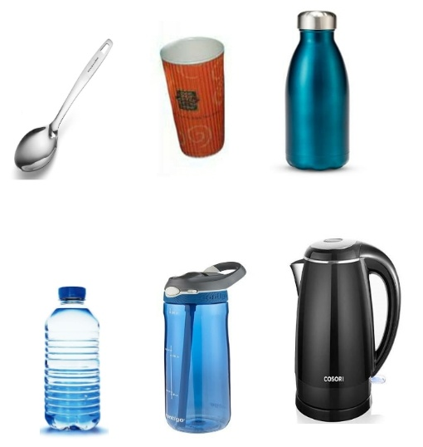 | Pouring water inside different containers
Step 4  Development – Groups Activities and Presentation  (15 minutes) | Guides pupils to –  Compare the container and tell which of them hold more or less water. |  | Comparing different containers based on their capabilities
Step 5  Conclusion  (10 minutes) | To conclude the lesson, the teacher revises the entire lesson and ask the key questions.  SUMMARY  The amount of substances or liquid a container can hold is called capacity.  Capacity of containers can be ordered.  Capacity of containers can be compared. | The learners listen, ask and answer questions.  KEY QUESTIONS  Draw a water bottle and a cup.  Water bottles hold more water than the cup. TRUE or FALSE. Base on their drawing. | Lesson Evaluation and Conclusion

Reference book – New Method Mathematics Book 2.
Instructional Materials

