LESSON DEVELOPMENT ONE

OBJECTS USED FOR MEASURING CAPACITY

STAGE/TIME | TEACHER’S ACTIVITIES | LEARNER'S ACTIVITIES – MIND/HANDS ON | LEARNING POINTS
Step 1  Introduction – Introductory Activities  (5 minutes) | Asks pupils –  Identify and name the following objects.  Discuss the uses of each object identified. | 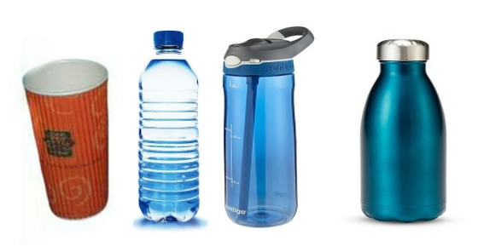  Cup, water bottle, filling bottle and flask. | Linking the Previous knowledge to the new lesson
Step 2  Development  (5 minutes)  Grouping | 1. Groups the learners into four groups – A, B, C, and D.  2. Guide the learners to choose a leader and secretary for your group.  3. Gives each group learning materials – sample or charts showing different containers such as spoons, cups, etc. A bucket of water. | 1. Belong to a group.  2. Choose their leader and secretary.  3. Received learning materials for their group. | Learner’s group, leader and secretary confirmed.
Step 3  Development – Groups Activities  (5 minutes) | Guides pupils to mention other containers used for water, tea, pap, kerosene, palm oil, ground oil. | Spoon,bucket, bottle, plate, gallon, etc. | Capacity used for different purposes
Step 4  Development – Groups Activities and Presentation  (15 minutes) | Guides pupils to –  Pour water into the containers.  Question – which of these hold much water? | 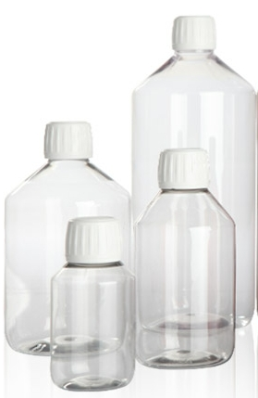 | Capacity of different containers
Step 5  Conclusion  (10 minutes) | To conclude the lesson, the teacher revises the entire lesson and ask the key questions.  SUMMARY  Different containers have different capabilities. Some are small. There are medium and bigger ones.  Small containers are spoons, cups, filling bottle, etc. The medium ones are gallon, bucket, etc. While drum and gallon, etc. are the bigger ones.  Container is used for holding or storing water, tea, etc. Capacity amount of liquid in a container. | The learners listen, ask and answer questions.  KEY QUESTIONS  1. _______ is used to hold water, tea, kerosene, etc.  (a) container  (b) capacity  (c) basket  2. _______ is the amount in a container.  (a) container  (b) capacity  (c) basket  3. _______ is used for taking liquid medicine (drug)  (a) spoon  (b) cup  (c) bucket | Lesson Evaluation and Conclusion

Reference book – New Method Mathematics Book 2.
Instructional Materials
