LESSON DEVELOPMENT TWO

CAPACITY OF A CONTAINERS

STAGE/TIME | TEACHER’S ACTIVITIES | LEARNER'S ACTIVITIES – MIND/HANDS ON | LEARNING POINTS
Step 1  Introduction – Introductory Activities  (5 minutes) | Asks pupils –  Examine the container on the chart (if real object not available).  Discuss the containers. | 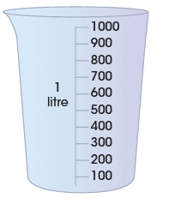 | Linking the Previous knowledge to the new lesson
Step 2  Development  (5 minutes)  Grouping | 1. Groups the learners into four groups – A, B, C, and D.  2. Guide the learners to choose a leader and secretary for your group.  3. Gives each group learning materials – Graduated litre jug. | 1. Belong to a group.  2. Choose their leader and secretary.  3. Received learning materials for their group. | Learner’s group, leader and secretary confirmed.
Step 3  Development – Groups Activities  (10 minutes) | Guides pupils to –  Use the graduated jug to fill the cooking pot with water.  Record the number of jug that filled the pot. The number of jugs is number of litre in the pot.  Use the pot to fill the bucket. Record the number of pot. The number of pots multiply by the number of litres in the pot.  Use the bucket to fill both basic and paint container. Record the number of buckets. The number of bucket multiply by the litres in bucket. | 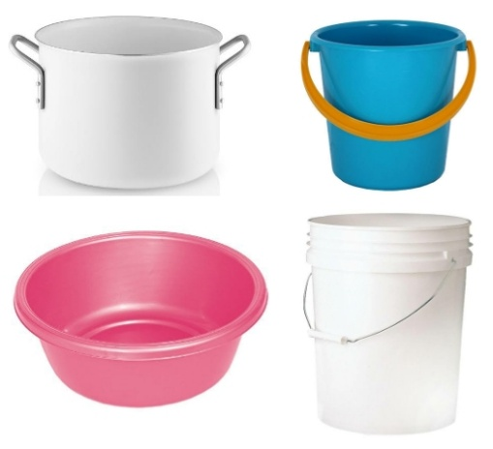  Follow the teacher’s instructions. | Capacity of containers
Step 4  Development – Groups Activities and Presentation  (15 minutes) | Inspects their activities and calls to report their findings. | Presentation | Capacity of different containers
Step 5  Development  (5 minutes) | To conclude the lesson, the teacher revises the entire lesson and ask the key questions.  SUMMARY  Different containers has different capacity. | The learners listen, ask and answer questions.  KEY QUESTIONS  What is capacity? | Lesson Evaluation and Conclusion

Reference book – New Method Mathematics Book 3.
Instructional Materials
