LESSON DEVELOPMENT ONE

IDENTIFYING THE LITRE AS A UNIT OF CAPACITY

STAGE/TIME | TEACHER’S ACTIVITIES | LEARNER'S ACTIVITIES – MIND/HANDS ON | LEARNING POINTS
Step 1  Introduction – Introductory Activities  (5 minutes) | Asks pupils –  Identify and name the following objects. | 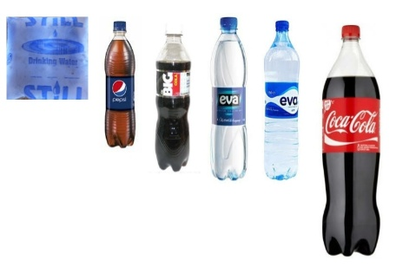  Pure water, Pepsi, Big coke, Eva water and Coke cola. | Linking the Previous knowledge to the new lesson
Step 2  Development  (5 minutes)  Grouping | 1. Groups the learners into four groups – A, B, C, and D.  2. Guide the learners to choose a leader and secretary for your group.  3. Gives each group learning materials – sample of different containers with accurate units. A bucket of water. | 1. Belong to a group.  2. Choose their leader and secretary.  3. Received learning materials for their group. | Learner’s group, leader and secretary confirmed.
Step 3  Development – Groups Activities  (10 minutes) | Makes a list of possible units of the following containers – 300ml, 50cl, 65cl, 75cl, 150cl and 1.75L.  Asks pupils to check the body of the containers and confirm each of the above units.  Tells the pupils that the above units are standard units of capacity.  The amount of water and mineral in each container is called its capacity. | Listen to teacher’s comments and understand the basic unit of capacity – ml, cl and L.  ml – millilitre  cl – centilitres  L – litre  The amount of liquid a container holds is called its capacity. | Standard unit of capacity  Liquids are things like: water, milk, kerosene, oil, petrol, juice, mineral water, etc.
Step 4  Development – Groups Activities and Presentation  (15 minutes) | Guides pupils to –  Pour water into the containers starting with the biggest ones.  Compare the difference.  Discuss while the units of these containers are different? |  | Capacity of different containers
Step 5  Development  (5 minutes) | To conclude the lesson, the teacher revises the entire lesson and ask the key questions.  SUMMARY  Liquids in large containers are measured in litres. Petrol and diesel are measured in litres.  Liquids in small containers are measured in millilitres. Syrups, lotions and perfumes are measured in millilitres. | The learners listen, ask and answer questions.  KEY QUESTIONS  1. Name five liquids measured in litres.  2. Name five liquids measured in centilitres.  3. Name five liquids measured in millilitres. | Lesson Evaluation and Conclusion

Reference book – New Method Mathematics Book 3.
Instructional Materials

