LESSON DEVELOPMENT ONE

ACTIVITIES OF THE DAY

STAGE/TIME | TEACHER’S ACTIVITIES | LEARNER'S ACTIVITIES – MIND/HANDS ON | LEARNING POINTS
Step 1  Introduction – Introductory Activities  (5 minutes) | Asks pupils to identify wristwatch and wall clock.  Note – don’t use chart, get the real objects.  Asks them to describe the wristwatch and wall clock.  Note – don’t mention the names of the objects. Asks, What is this? |  | Linking the Previous knowledge to the new lesson
Step 2  Development  (5 minutes)  Grouping | 1. Groups the learners into four groups – A, B, C, and D.  2. Guide the learners to choose a leader and secretary for your group.  3. Gives each group learning materials – wristwatch and wall clock, charts. | 1. Belong to a group.  2. Choose their leader and secretary.  3. Received learning materials for their group. | Learner’s group, leader and secretary confirmed.
Step 3  Development – Groups Activities  (5 minutes) | Lets them study carefully.  Guides pupils to identify the minutes and hours hands on the clock. | The minutes hand is blue while the hours hand is red.  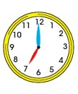 | Identification of hour and minutes hands.
Step 4  Development – Groups Activities and Presentation  (15 minutes) | GUIDED INSTRUCTIONS  Asks each group one by one question based on the activities on the chart.  Guides and Asks them exactly time and period (morning, afternoon, evening or night) the activities take place. | 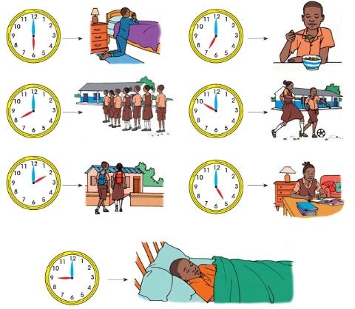 | Activities of the day
Step 5  Conclusion  (10 minutes) | To conclude the lesson, the teacher revises the entire lesson and ask the key questions. | The learners listen, ask and answer questions. | Lesson Evaluation and Conclusion

Reference book – New Method Mathematics Book 1.
Instructional Materials

