LESSON DEVELOPMENT THREE

DRAWING THE HANDS ON THE CLOCK FACE

STAGE/TIME | TEACHER’S ACTIVITIES | LEARNER'S ACTIVITIES – MIND/HANDS ON | LEARNING POINTS
Step 1  Introduction – Introductory Activities  (5 minutes) | Asks pupils –  Which of these represent minutes or hours hand? |  | Linking the Previous knowledge to the new lesson
Step 2  Development  (5 minutes)  Grouping | 1. Groups the learners into four groups – A, B, C, and D.  2. Guide the learners to choose a leader and secretary for your group.  3. Gives each group learning materials – clocks, a cut color cardboard to represent blue minutes hand and red hours hand. Color pens. | 1. Belong to a group.  2. Choose their leader and secretary.  3. Received learning materials for their group. | Learner’s group, leader and secretary confirmed.
Step 3  Development – Groups Activities  (5 minutes) | Guides asks pupils to –  Draw the minutes and hours hands on clock face. | 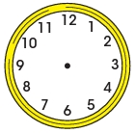 | Drawing clock face with time
Step 4  Development – Groups Activities and Presentation  (15 minutes) | Guides pupils to –  Put the minutes hand on 12 and hours hand on 7 on the clock face.  Do the same with other clock faces. | 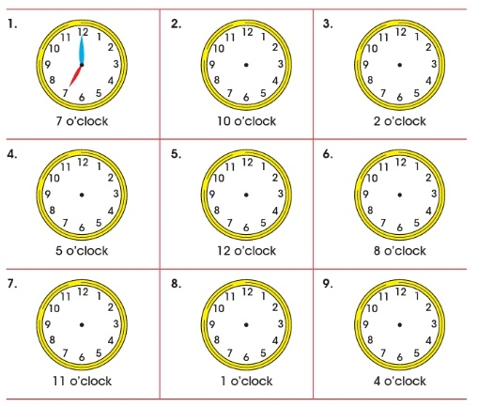 | Showing time on clock faces.
Step 5  Conclusion  (10 minutes) | To conclude the lesson, the teacher revises the entire lesson and ask the key questions. | The learners listen, ask and answer questions. | Lesson Evaluation and Conclusion

Reference book – New Method Mathematics Book 1.
Instructional Materials

