LESSON DEVELOPMENT TWO

TELLING TIME IN HOURS

STAGE/TIME | TEACHER’S ACTIVITIES | LEARNER'S ACTIVITIES – MIND/HANDS ON | LEARNING POINTS
Step 1  Introduction – Introductory Activities  (5 minutes) | Asks pupils –  What is the color of minutes hand?  What is the color of hour hand?  The minutes hand is on what number.  The hours hand is on what hand.  What is the time on the clock.? | Minutes hand is blue.  Hour hands is red.  Minutes is on 12.  Hours hand is on 11.  The time is 11 o’clock or 12 o’clock (Expected Answer). | 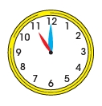  Linking the Previous knowledge to the new lesson
Step 2  Development  (5 minutes)  Grouping | 1. Groups the learners into four groups – A, B, C, and D.  2. Guide the learners to choose a leader and secretary for your group.  3. Gives each group learning materials – clocks and charts showing time on clock faces. A cut color cardboard to represent blue minutes hand and red hours hand. | 1. Belong to a group.  2. Choose their leader and secretary.  3. Received learning materials for their group. | Learner’s group, leader and secretary confirmed.
Step 3  Development – Groups Activities  (5 minutes) | Tells pupils that when minutes hand is on 12 and hours hand is on 11, the time is 11 o’clock.  Also, when minutes hand is on 12 and hours hand is on 1, the time is 1 o’clock. | 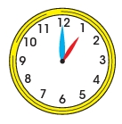 | Time in hours
Step 4  Development – Groups Activities and Presentation  (15 minutes) | GUIDED INSTRUCTIONS  Asks each group a question after the other –  What time is the -  1. Boy praying?  2. Boy eating?  3. Boys and Girls on the assembly ground?  4. Boy and girl playing football?  5. Boy and girl going home?  6. Girl doing her homework?  7. Boy sleeping. | 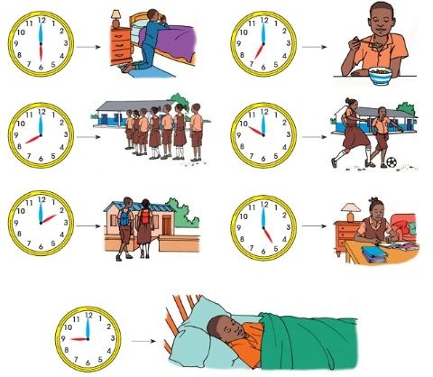 | Telling time in hours
Step 5  Conclusion  (10 minutes) | To conclude the lesson, the teacher revises the entire lesson and ask the key questions. | The learners listen, ask and answer questions. | Lesson Evaluation and Conclusion

Reference book – New Method Mathematics Book 1.
Instructional Materials

