LESSON DEVELOPMENT ONE

MEANING OF HEAT

STAGE/TIME | TEACHER’S ACTIVITIES | LEARNER'S ACTIVITIES – MIND/HANDS ON | LEARNING POINTS
Step 1  Introduction – Introductory Activities  (5 minutes) | Asks pupils to –  1. Identify the following objects on the charts.  2. Describe the use(s) of identified objects.  3. Why do we cook in the kitchen and not inside the room? (possible answer – heat). | 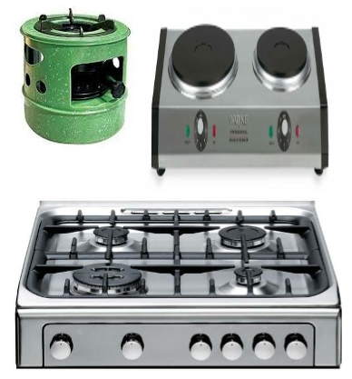  Kerosene stove, electric and gas cooker. They are used for cooking. | Linking the Previous knowledge to the new lesson
Step 2  Development  (5 minutes)  Grouping | 1. Groups the learners into four groups – A, B, C, and D.  2. Guide the learners to choose a leader and secretary for your group.  3. Gives each group learning materials – sample of any of the items on chart. | 1. Belong to a group.  2. Choose their leader and secretary.  3. Received learning materials for their group. | Learner’s group, leader and secretary confirmed.
Step 3  Development – Groups Activities  (5 minutes) | Asks pupils to mention some of the sources of heat they know. | Burning of wood, Sun, Electric bulb, Candle, Engine, etc. | Source of heat
Step 4  Development – Groups Activities  (10 minutes) | Asks pupils to –  1. What do you understand by heat?  2. What are the importance of heat. | Heat is a form of energy that increases the level of hotness of a body.  It is important for cooking, frying, drying, baking, generating electricity, water circle, plants, melting and molding metal, etc. | Meaning and importance of heat.
Step 5  Development  (10 minutes) | Asks each group to present their results/solutions so that you can compare responses with those in other groups. | Presentation | Group Presentation
Step 6  Conclusion  (10 minutes) | To conclude the lesson, the teacher revises the entire lesson and ask the key questions.  SUMMARY  Heat is a form of energy which exists naturally. It increases the level of hotness of a body.  Life on this earth depends on heat energy for survival. | The learners listen, ask and answer questions.  KEY QUESTIONS  1. What is heat?  2. Mention 5 importance of heat.  3. State 5 sources of heat. | Lesson Evaluation and Conclusion

Reference book – Primary 5 Basic Science & Technology

