LESSON DEVELOPMENT THREE

THERMOMETER

STAGE/TIME | TEACHER’S ACTIVITIES | LEARNER'S ACTIVITIES – MIND/HANDS ON | LEARNING POINTS
Step 1  Introduction – Introductory Activities  (5 minutes) | Heat and temperature are related to each other, but are different concepts.  Asks pupils to differentiate between heat and water temperature. | Heat is a form of energy that increases the level of hotness of a body.  While temperature is the hotness or coldness of an object – weather, body, water, air, etc. | Linking the Previous knowledge to the new lesson
Step 2  Development  (5 minutes)  Grouping | 1. Groups the learners into four groups – A, B, C, and D.  2. Guide the learners to choose a leader and secretary for your group.  3. Gives each group learning materials – warm, hot, cool and cold water. Thermometer. | 1. Belong to a group.  2. Choose their leader and secretary.  3. Received learning materials for their group. | Learner’s group, leader and secretary confirmed.
Step 3  Development – Groups Activities  (5 minutes) | Explains to pupils that we detect hotness and coldness inaccurately.  To measure how hot or cold an object is, we use a thermometer.  This tells us the temperature of the object. | 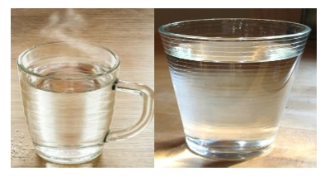  The pupils listen to the teacher’s explanation. Understand that thermometer is used for measuring temperature | Instructions used for measuring thermometer
Step 4  Development – Groups Activities  (10 minutes) | Tells pupils that when a substance is hot, the temperature is high and when the substance is less hot then the temperature is lower.  Shows pupils a thermometer (if available).  Guides them to use thermometer to measure the level of hotness or coldness of water.  Asks them to observe and describe their observations.  Asks pupils – what Is a thermometer? | Listen to teacher’s explanation about increase and decrease in temperature.  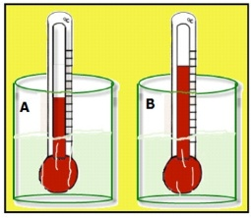  Examine the thermometer.  Follow the teacher’s instructions on how to use thermometer.  In the hot water, the liquid inside the thermometer goes up and drop in the cold water.  Thermometer is used for measuring temperature. | High and low temperature.  Meaning of thermometer.
Step 5  Development  (10 minutes) | Asks each group to present their results/solutions so that you can compare responses with those in other groups. | Presentation | Group Presentation
Step 6  Conclusion  (10 minutes) | To conclude the lesson, the teacher revises the entire lesson and ask the key questions.  SUMMARY  Temperature is the degree of hotness or coldness of an object. To measure how hot or cold an object is, we use a thermometer. | The learners listen, ask and answer questions.  KEY QUESTIONS  What is the different between temperature and thermometer? | Lesson Evaluation and Conclusion

Reference book – Primary 5 Basic Science & Technology

