LESSON DEVELOPMENT ONE

MEANING OF MAGNETISM

STAGE/TIME | TEACHER’S ACTIVITIES | LEARNER'S ACTIVITIES – MIND/HANDS ON | LEARNING POINTS
Step 1  Introduction – Introductory Activities  (5 minutes) | Asks pupils to identify this object (preferable, real objects) on the chart.  Where do can we this type of magnet? | 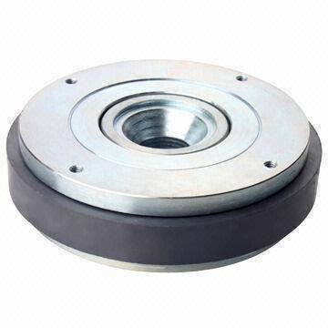  Magnet. We can get from speaker. | Linking the Previous knowledge to the new lesson
Step 2  Development  (5 minutes)  Grouping | 1. Groups the learners into four groups – A, B, C, and D.  2. Guide the learners to choose a leader and secretary for your group.  3. Gives each group learning materials – magnets, magnetic and non – magnetic materials. | 1. Belong to a group.  2. Choose their leader and secretary.  3. Received learning materials for their group. | Learner’s group, leader and secretary confirmed.
Step 3  Development – Groups Activities  (5 minutes) | Ask pupils to -  Identify the following:  1. Magnets  2. Magnetic materials  3. Magnetic materials.  Makes provision for the following as stated in the chart. | 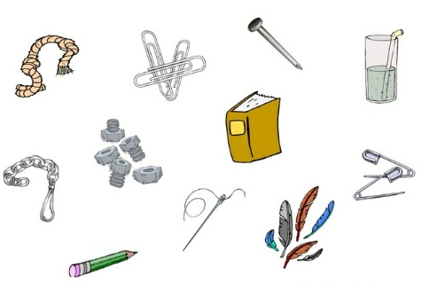 | Magnetic and non magnetic materials
Step 4  Development – Groups Activities  (10 minutes) | Asks the groups to use magnet to copy and complete the table.  Keys  A – Object  B – Magnetic materials  C – Non magnetic materials  Asks them to explain the following –  1. Magnet  2. Magnetic materials  3. Non magnetic materials | A B C | Meaning of magnet, magnetic and non magnetic materials.
Step 5  Development  (10 minutes) | Asks each group to present their results/solutions so that you can compare responses with those in other groups. | Presentation | Group Presentation
Step 6  Conclusion  (10 minutes) | To conclude the lesson, the teacher revises the entire lesson and ask the key questions.  SUMMARY  A magnet is an object that can attract iron mater to itself.  Magnetic materials are materials can be attracted by magnet.  While non magnetic materials are materials that cannot be attracted by magnet. | The learners listen, ask and answer questions.  KEY QUESTIONS  Write a short on the following  1. MAGNET  2. MAGNETIC MATERIALS with 5 examples of magnetic materials.  3. NON MAGNETIC MATERIALS with 5 non magnetic materials. | Lesson Evaluation and Conclusion

Reference book – Primary 6 Basic Science & Technology

