LESSON DEVELOPMENT THREE

USES OF MAGNETS

STAGE/TIME | TEACHER’S ACTIVITIES | LEARNER'S ACTIVITIES – MIND/HANDS ON | LEARNING POINTS
Step 1  Introduction – Introductory Activities  (5 minutes) | Asks pupils - what are the properties of Magnets? | Properties of Magnets  1. Magnets attract magnets  2. Opposite poles attract one another.  3. Like poles push one another away (repel).  4. Magnets attract objects of iron, cobalt and nickel. | Linking the Previous knowledge to the new lesson
Step 2  Development  (5 minutes)  Grouping | 1. Groups the learners into four groups – A, B, C, and D.  2. Guide the learners to choose a leader and secretary for your group.  3. Gives each group learning materials – sample/chart of radio, television, telephone, speaker, electric generator, electric bell, ammeter, etc. | 1. Belong to a group.  2. Choose their leader and secretary.  3. Received learning materials for their group. | Learner’s group, leader and secretary confirmed.
Step 3  Development – Groups Activities  (5 minutes) | Lets pupils identify the items on the chart. | 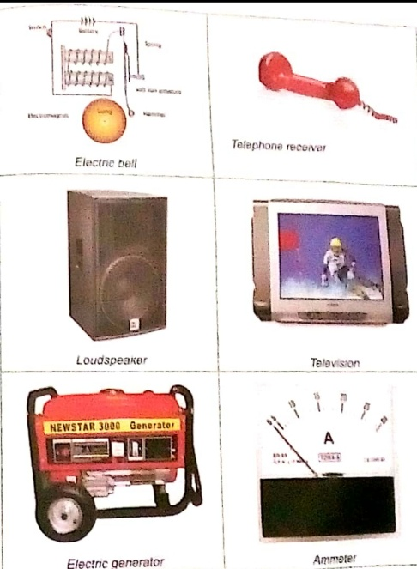 | North and South Poles of a Magnets
Step 4  Development – Groups Activities  (10 minutes) | Guided Instructions –  If a magnet is found in a speaker, microphone, mobile phone, computer, television, etc. what are usefulness of magnets in the mentioned item? |  | Properties of Magnets
Step 5  Development  (10 minutes) | Asks each group to present their results/solutions so that you can compare responses with those in other groups. | Presentation | Group Presentation
Step 6  Conclusion  (10 minutes) | To conclude the lesson, the teacher revises the entire lesson and ask the key questions.  SUMMARY  Magnets can be affected by electricity, which makes them very useful in machines and computers.  Magnets are used to make a tight seal on the doors to refrigerators and freezers.  They power speakers, earphones and television.  Magnets are used to store data in computer. | The learners listen, ask and answer questions.  KEY QUESTIONS –  Make a note of uses of Magnets in your notebook. | Lesson Evaluation and Conclusion

Reference book – Primary 6 Basic Science & Technology

