LESSON DEVELOPMENT TWO

LINES OF SYMMETRY – QUADRILATERALS

STAGE/TIME | TEACHER’S ACTIVITIES | LEARNER'S ACTIVITIES – MIND/HANDS ON | LEARNING POINTS
Step 1  Introduction – Introductory Activities  (5 minutes) | 1. Draw a line.  2. Draw another line from the starting or end of the first line.  3. Draw another line from other end.  4. Draw one more to join the four lines together.  5. How many lines and altogether?  6. What shape do you think is this?  7. This shape has many corners?  Note – Lets pupils know that the shape is called quadrilateral. | 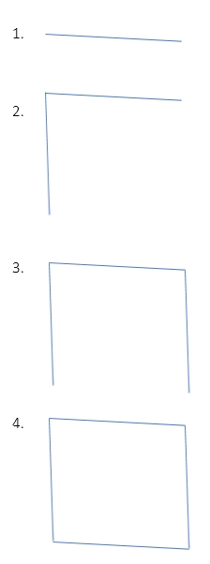  5. 4 lines and 4 angles.  6. Square or rectangle, depend on what the pupils draw.  7. 4 corners. | Linking the Previous knowledge to the new lesson
Step 2  Development  (5 minutes)  Grouping | 1. Groups the learners into four groups – A, B, C, and D.  2. Guide the learners to choose a leader and secretary for your group.  3. Gives each group learning materials – plain papers, mathematical sets with long rulers and sample/chart of square and rectangle. | 1. Belong to a group.  2. Choose their leader and secretary.  3. Received learning materials for their group. | Learner’s group, leader and secretary confirmed.
Step 3  Development – Groups Activities  (5 minutes) | Guides each group to measure the sides (lines) of square and rectangle.  Lets them compare their measurements with one another, then wrap up.  The 1st shape is called a square. While the 2nd shape is called rectangle. Asks them to differentiate between square and rectangle. | In 1st shape has all sides (lines) equal. While the 2nd shape has two opponent sides (lines) equal.  Square is a shape that has all sides equal while rectangle has two opposite sides equal. | Identification of square and rectangle
Step 4  Development – Groups Activities  (10 minutes) | GUIDED INSTRUCTIONS  Guides the groups to fold or divide each of the shapes into two or more equal similar parts (if possible).  Asks them how many times each shape can be folded or divided. | 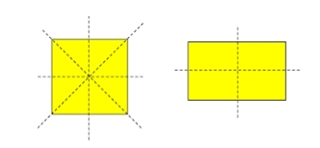  Square – 4 times  Rectangle – 2 times | Lines of symmetry
Step 5  Development – Presentation  (10 minutes) | Asks each group to present their results/solutions so that you can compare responses with those in other groups. | Presentation – Call on any member of at least two pairs in each to make presentation to the class. | Group Presentation
Step 7  Conclusion  (5 minutes) | To conclude the lesson, the teacher revises the entire lesson and ask the key questions.  SUMMARY  Lines of symmetry divide a shape into two or more equal similar parts.  KEY QUESTIONS –  1. A square triangle has ______ equal sides. (a) 1 (b) 2 (c) 3 (d) 4 | The learners listen, ask and answer questions.  KEY QUESTIONS –  2. A rectangle triangle has ______ line of symmetry. (a) 1 (b) 2 (c) 3 (d) 4  3. A square triangle has ______ line of symmetry. (a) 1 (b) 2 (c) 3 (d) 4  4. A rectangle triangle has ______ equal sides. (a) 1 (b) 2 (c) 3 (d) 4 | Lesson Evaluation and Conclusion

Reference book – New Method Mathematics Book
Instructional Materials

