LESSON DEVELOPMENT ONE

LINES OF SYMMETRY – TRIANGLES

STAGE/TIME | TEACHER’S ACTIVITIES | LEARNER'S ACTIVITIES – MIND/HANDS ON | LEARNING POINTS
Step 1  Introduction – Introductory Activities  (5 minutes) | 1. Draw a line.  2. Draw another line from the starting or end of the first line. 3. How many lines have you drawn?  4. Draw another line to join the first and second lines together.  5. How many lines altogether?  6. What shape do you think is this?  7. What is a triangle?  Note – Lets pupils know that triangle also has three angles and corners (vertices). | 1.  2.  3. 2 lines.  4.  5. 3 lines  6. Triangle  7. A triangle is a shape with three lines or sides.  Listen to teacher’s explanation and identify vertices and angles in a triangle. | Linking the Previous knowledge to the new lesson
Step 2  Development  (5 minutes)  Grouping | 1. Groups the learners into four groups – A, B, C, and D.  2. Guide the learners to choose a leader and secretary for your group.  3. Gives each group learning materials – plain papers, mathematical sets with long rulers and chart showing different types of triangles. | 1. Belong to a group.  2. Choose their leader and secretary.  3. Received learning materials for their group. | Learner’s group, leader and secretary confirmed.
Step 3  Development – Groups Activities  (5 minutes) | Guides each group to measure each types of triangles – equilateral, isosceles, scalene and right angle triangles.  Lets them compare their measurements with one another, then wrap up.  Wrap up – The 1st triangle is called equilateral triangle. The 2nd triangle is called isosceles triangle. The 3rd triangle is called scalene triangle. While the 4th triangle is called right angle triangle. | 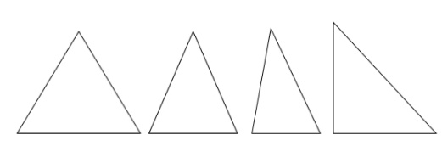  In 1st triangle, all lines (sides) are equal. 2nd triangle, only two lines (sides) are equal. 3rd triangle, no equal lines.  Listen to teacher’s warp up and understand different types of triangles according to their sides (lines). | Types of Triangles – equilateral, isosceles, scalene and right angle triangles.
Step 4  Development – Groups Activities  (10 minutes) | GUIDED INSTRUCTIONS  Guides the groups to fold or divide each of the shapes into two or more equal similar parts (if possible).  Asks them how many times each shape can be folded or divided. | 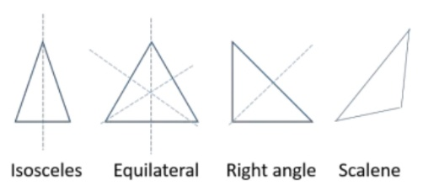  Equilateral triangle – 3 times  Isosceles triangle – 1 times  Scalene triangle - 0  Right angle triangle (isosceles type) – 1 times | Lines of symmetry
Step 5  Development – Presentation  (10 minutes) | Asks each group to present their results/solutions so that you can compare responses with those in other groups. | Presentation – Call on any member of at least two pairs in each to make presentation to the class. | Group Presentation
Step 7  Conclusion  (5 minutes) | To conclude the lesson, the teacher revises the entire lesson and ask the key questions.  SUMMARY  Lines of symmetry divide a shape into two or more equal similar parts.  KEY QUESTIONS –  1. An equilateral triangle has ______ equal sides. (a) 0 (b) 1 (c) 2 (d) 3  2. An isosceles triangle has ______ line of symmetry. (a) 0 (b) 1 (c) 2 (d) 3 | The learners listen, ask and answer questions.  KEY QUESTIONS –  3. A scalene triangle has ______ line of symmetry. (a) 0 (b) 1 (c) 2 (d) 3  4. An equilateral triangle has ______ line of symmetry. (a) 0 (b) 1 (c) 2 (d) 3  5. A isosceles triangle has ______ equal sides. (a) 0 (b) 1 (c) 2 (d) 3  6. A scalene triangle has ______ equal sides. (a) 0 (b) 1 (c) 2 (d) 3 | Lesson Evaluation and Conclusion

Reference book – New Method Mathematics Book
Instructional Materials

