LESSON DEVELOPMENT THREE

HORIZONTAL AND VERTICAL LINES

STAGE/TIME | TEACHER’S ACTIVITIES | LEARNER'S ACTIVITIES – MIND/HANDS ON | LEARNING POINTS
Step 1  Introduction – Introductory Activities  (5 minutes) | Asks pupils to look at the chart carefully and describe what they see.  The four arrow are called 4 cardinal points. They represent direction or location of a place on the map.  The letters are North (N), South (S), East € and West (W) | 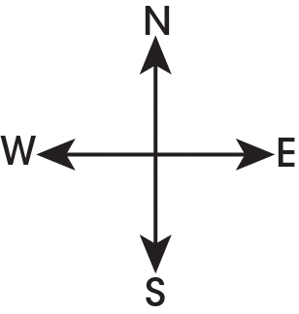  Probably, they will mention 4 arrow with letters – N, S, E and W. | Linking the Previous knowledge to the new lesson – 4 cardinal points
Step 2  Development  (5 minutes)  Grouping | 1. Groups the learners into four groups – A, B, C, and D.  2. Guide the learners to choose a leader and secretary for your group.  3. Gives each group learning materials – sample/chart of cardinal points. | 1. Belong to a group.  2. Choose their leader and secretary.  3. Received learning materials for their group. | Learner’s group, leader and secretary confirmed.
Step 3  Development – Groups Activities  (5 minutes) | The four cardinal points are further divided into 8 cardinal points.  For example, between North and East will have North – East (NE).  Find other cardinal between South and East, South and West and North West. | 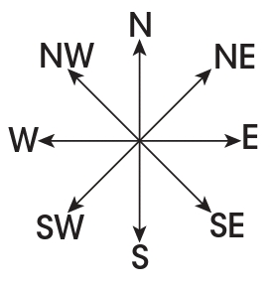 | 8 cardinal points
Step 4  Development – Groups Activities  (10 minutes) | GUIDED INSTRUCTIONS  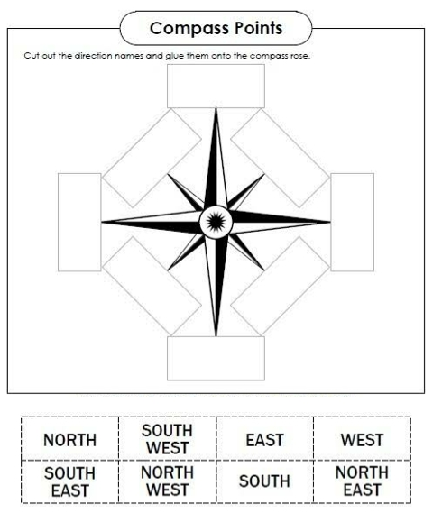 |  | Groups work
Step 5  Development – Presentation  (10 minutes) | Asks each group to present their results/solutions so that you can compare responses with those in other groups. | Presentation – Call on any member of at least two pairs in each to make presentation to the class. | Group Presentation
Step 7  Conclusion  (5 minutes) | To conclude the lesson, the teacher revises the entire lesson and ask the key questions.  KEY QUESTIONS – The map below shows Nigeria and some other African countries. Study it carefully.  Nigeria is South of Niger Republic  2. Chad Republic is _____ of Nigeria  3. Benin Republic is _____ of Nigeria. | The learners listen, ask and answer questions.  KEY QUESTIONS  4. _____ is both East and South East of Nigeria.  5. _____ is both North and North West of Nigeria.  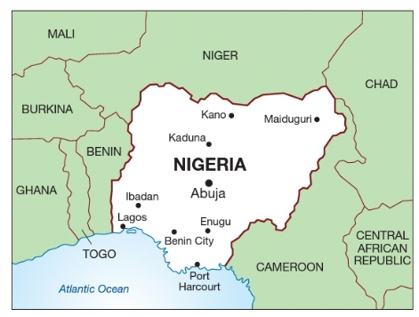 | Lesson Evaluation and Conclusion

Reference book – New Method Mathematics Book
Instructional Materials

