LESSON DEVELOPMENT THREE

HORIZONTAL AND VERTICAL LINES

STAGE/TIME | TEACHER’S ACTIVITIES | LEARNER'S ACTIVITIES – MIND/HANDS ON | LEARNING POINTS
Step 1  Introduction – Introductory Activities  (5 minutes) | 1. Draw 5 different lines.  2. Compare each of your line with these two lines. |  | Linking the Previous knowledge to the new lesson
Step 2  Development  (5 minutes)  Grouping | 1. Groups the learners into four groups – A, B, C, and D.  2. Guide the learners to choose a leader and secretary for your group.  3. Gives each group learning materials – cube or cuboid cartoon. | 1. Belong to a group.  2. Choose their leader and secretary.  3. Received learning materials for their group. | Learner’s group, leader and secretary confirmed.
Step 3  Development – Groups Activities  (5 minutes) | Lets pupils identify the lines by names – horizontal and vertical lines.  Guides them to differentiate between horizontal and vertical lines with practical illustrations – vertical (standing) and horizontal (lying down) |  | Identification of horizontal and vertical lines by names.
Step 4  Development – Groups Activities  (10 minutes) | GUIDED INSTRUCTIONS  When 3 or more lines joined together, they formed a shape.  How many line formed this shape?  How many of these lines are vertical and horizontal lines.  The face of this shape looks like square or rectangular face?  Name five (5) shapes that the represent – for example, Maggi cube. | 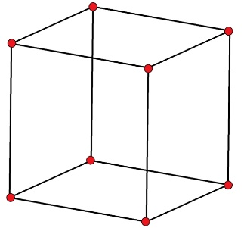  The shape has 12 lines.  It has 4 vertical lines and 8 horizontal lines.  It has a square faces.  Cube of sugar, cartoon, a room, classroom and table top fridge. | Vertical and horizontal lines
Step 5  Development – Presentation  (10 minutes) | Asks each group to present their results/solutions so that you can compare responses with those in other groups. | Presentation – Call on any member of at least two pairs in each to make presentation to the class. | Group Presentation
Step 7  Conclusion  (5 minutes) | To conclude the lesson, the teacher revises the entire lesson and ask the key questions.  KEY QUESTIONS –  How many vertical (V) and horizontal (H) are in the following shapes? | The learners listen, ask and answer questions.  H ____, V ____  …. H ____, V ____  …. H ____, V ____ | Lesson Evaluation and Conclusion

Reference book – New Method Mathematics Book
Instructional Materials

