LESSON DEVELOPMENT SEVEN

INTERPRETING PIE CHARTS

STAGE/TIME | TEACHER’S ACTIVITIES | LEARNER'S ACTIVITIES – MIND/HANDS ON | LEARNING POINTS
Step 1  Introduction – Introductory Activities  (10 minutes) | Asks the pupils draw a circle.  Guides them to divide the circle into two (2) equal parts. Further divide one of the semi circles into two (2) parts (not equal). And the other semi circle into two (2) parts (not equal).  Asks the pupils to five (5) different fruits on each part of the circle.  Tells them that each part representing different fruits is called a pie (slice) chart. | 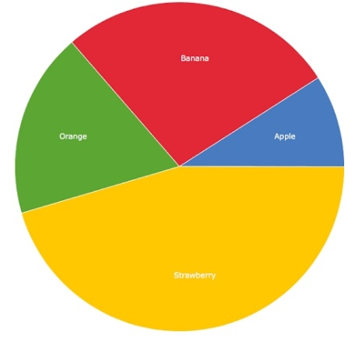 | Linking the Previous knowledge to the new lesson
Step 2  Development  (5 minutes)  Grouping | 1. Groups the learners into four groups – A, B, C, and D.  2. Guide the learners to choose a leader and secretary for your group.  3. Gives each group learning materials – chart showing different data – fruits, electronics, states, food, etc. Mathematical sets. | 1. Belong to a group.  2. Choose their leader and secretary.  3. Received learning materials for their group. | Learner’s group, leader and secretary confirmed.
Step 3  Development – Groups Activities  (10 minutes) | Guides the pupils to use their protractor to measure the size of each fruits. |  | Angles in a pie chart
Step 4  Development – Groups Activities  (10 minutes) | Measure the angle of each means of land transportation.  Car  Bus  Walk  Taxi  Cycle  Car | 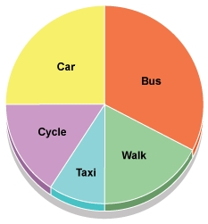 | Groups Activities
Step 5  Development – Presentation  (10 minutes) | Asks each group to present their results/solutions so that you can compare responses with those in other groups. | Presentation – Call on any member of at least two pairs in each to make presentation to the class. | Group Presentation
Step 7  Conclusion  (5 minutes) | To conclude the lesson, the teacher revises the entire lesson and ask the key questions.  SUMMARY  A pie chart is a chart in which a circle is divided into sectors that each represent a proportion of the whole. It used number, degree or percentage to represent the size of each part. | The learners listen, ask and answer questions.  KEY QUESTIONS (ASSIGNMENT)  Draw a pie representing the following –  Television 40%  Radio 20%  Mobile phone 80%  Computer 30%  Toy 10% | Lesson Evaluation and Conclusion

Reference book – New Method Mathematics

