LESSON DEVELOPMENT THREE

TALLY MARKS AND FREQUENCY TABLES

STAGE/TIME | TEACHER’S ACTIVITIES | LEARNER'S ACTIVITIES – MIND/HANDS ON | LEARNING POINTS
Step 1  Introduction – Introductory Activities  (5 minutes) | Guides and asks pupils to write number 1 to 10 and corresponding strokes. | 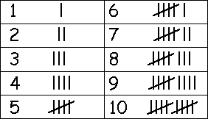 | Linking the Previous knowledge to the new lesson
Step 2  Development  (5 minutes)  Grouping | 1. Groups the learners into four groups – A, B, C, and D.  2. Guide the learners to choose a leader and secretary for your group.  3. Gives each group learning materials – chart showing different data. | 1. Belong to a group.  2. Choose their leader and secretary.  3. Received learning materials for their group. | Learner’s group, leader and secretary confirmed.
Step 3  Development – Groups Activities  (5 minutes) | Lets pupils count the tally marks and write the total in the box.  Tells them that the total tally marks are called frequency. | 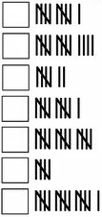 | Tally marks and frequency
Step 4  Development – Groups Activities  (10 minutes) | GUIDED INSTRUCTIONS  Class 6 children carried out a survey to find out the number of letters in the names of children in their school. This is what they discovered.  1. Copy and complete the frequency table.  2. How many letters does the highest tally have?  3. How many letters does the lowest tally have?  4. How many pupils are in class 6? | 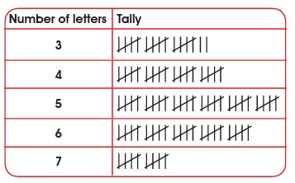  Nos of letters Frequency  3  4  5  6  7  Total | Tally marks and frequency table
Step 5  Development – Presentation  (10 minutes) | Asks each group to present their results/solutions so that you can compare responses with those in other groups. | Presentation – Call on any member of at least two pairs in each to make presentation to the class. | Group Presentation
Step 7  Conclusion  (5 minutes) | To conclude the lesson, the teacher revises the entire lesson and ask the key questions.  KEY QUESTIONS  The table below shows the marks scored by class six pupils in a test.  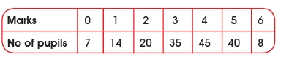 | The learners listen, ask and answer questions.  KEY QUESTIONS –  1. Draw the tally marks.  2. Draw a bar graph to show this information.  3. How many pupils scored less than 3 marks?  4. Find the number of pupils in class 6. | Lesson Evaluation and Conclusion

Reference book – New Method Mathematics

