LESSON DEVELOPMENT FOUR

DISTINGUISHING BETWEEN CUBES AND CUBOIDS

STAGE/TIME | TEACHER’S ACTIVITIES | LEARNER'S ACTIVITIES – MIND/HANDS ON | LEARNING POINTS
Step 1  Introduction – Introductory Activities  (5 minutes) | Guides pupils to identify the following three dimensional shapes.  Asks them to give examples of real three dimensional shapes from the chart. | 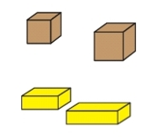  Cube – sugar cube and dice.  Cuboid – bread and block. | Linking the Previous knowledge to the new lesson
Step 2  Development  (5 minutes)  Grouping | 1. Groups the learners into four groups – A, B, C, and D.  2. Guide the learners to choose a leader and secretary for your group.  3. Gives each group learning materials – samples/chart showing real solid shapes. | 1. Belong to a group.  2. Choose their leader and secretary.  3. Received learning materials for their group. | Learner’s group, leader and secretary confirmed.
Step 3  Development – Groups Activities  (15 minutes) | Study the chart carefully.  Guides the pupils to compare each solid cube with solid cuboid by letting them to observe their basic features. | 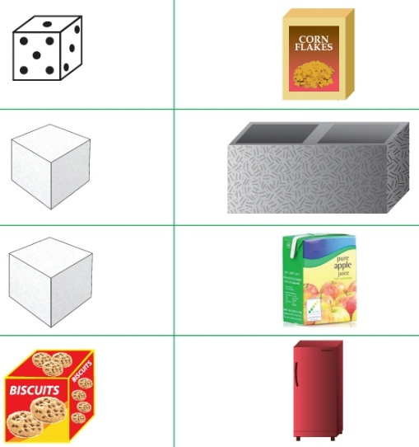 | Comparing cube and cuboid
Step 4  Development – Groups Activities and Presentation  (10 minutes) | Asks the pupils to say Yes or No for each sentence.  1. Are the objects in boxes A and B similar? Yes/No  2. What do you notice about the lengths of the sides of each shape in box A?  3. What do you notice about the lengths of the sides of each shape in box B? |  | Differentiating between solid cube and cuboid
Step 5  Development  (5 minutes) | To conclude the lesson, the teacher revises the entire lesson and ask the key questions.  SUMMARY  Solid objects can be classified as cubes, cuboids, cylinders and spheres.  KEY QUESTIONS  Classify the following solid shapes as cube, cuboid, cylinder and spheres. Copy and complete the sentences. | The learners listen, ask and answer questions.  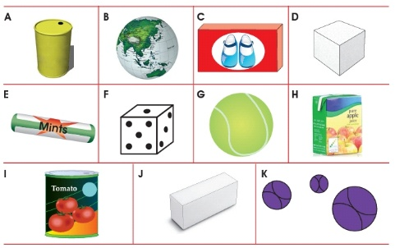  1. The cubes are…..  2. The cuboids are….  3. The cylinders are  4. The spheres are….. | Lesson Evaluation and Conclusion

Reference book – New Method Mathematics Book 1 2 3

Instructional Materials
