LESSON DEVELOPMENT TWO

IDENTIFYING AND NAMING SOLID SHAPES

STAGE/TIME | TEACHER’S ACTIVITIES | LEARNER'S ACTIVITIES – MIND/HANDS ON | LEARNING POINTS
Step 1  Introduction – Introductory Activities  (5 minutes) | 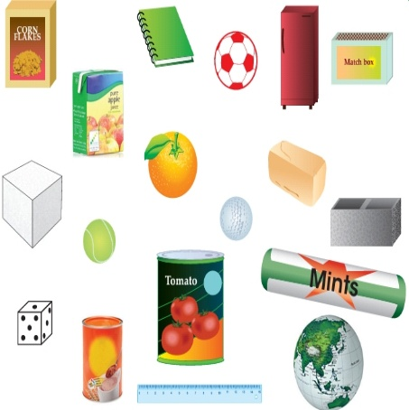  Allows pupils to mention the name of the items that belong to the same group. | 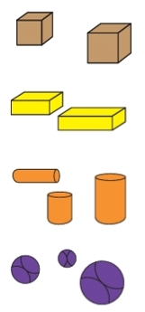 | Linking the Previous knowledge to the new lesson
Step 2  Development  (5 minutes)  Grouping | 1. Groups the learners into four groups – A, B, C, and D.  2. Guide the learners to choose a leader and secretary for your group.  3. Gives each group learning materials – samples/chart showing 3 dimensional shapes. | 1. Belong to a group.  2. Choose their leader and secretary.  3. Received learning materials for their group. | Learner’s group, leader and secretary confirmed.
Step 3  Development – Groups Activities  (10 minutes) | Study and identify the objects drawn below.  They are called three - dimensional or solid shapes.  Discusses with the pupils cube, cuboid, cylinder and sphere with examples of real objects. | 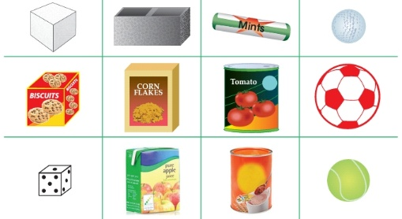  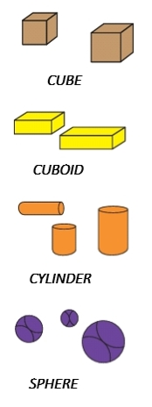 | Identifying cube, cuboid, cylinder and sphere
Step 4  Development – Groups Activities and Presentation  (15 minutes) | Use the pictures  to write the name of the solid shapes as cube, cuboid, cylinder, sphere. | Cubd Cuboid Cylinder Sphere  Dice Match box Tin tomato Ball | Identifying real objects according to their shapes – cube, cuboid, cylinder and sphere
Step 5  Development  (5 minutes) | To conclude the lesson, the teacher revises the entire lesson and ask the key questions.  KEY QUESTIONS  Choose the name of each object drawn in the left column from the shape names in the right column. | The learners listen, ask and answer questions.  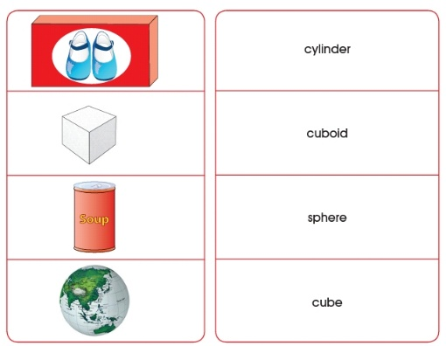 | Lesson Evaluation and Conclusion

Reference book – New Method Mathematics Book 1 2 3
Instructional Materials
