LESSON DEVELOPMENT THREE

OBJECTS IN OUR ENVIRONMENT THAT ARE THREE - DIMENSIONAL SHAPES

STAGE/TIME | TEACHER’S ACTIVITIES | LEARNER'S ACTIVITIES – MIND/HANDS ON | LEARNING POINTS
Step 1  Introduction – Introductory Activities  (5 minutes) | Guides pupils to identify the following three dimensional shapes.  Asks them to give examples of real three dimensional shapes from the chart. | 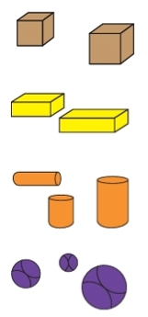 | Linking the Previous knowledge to the new lesson
Step 2  Development  (5 minutes)  Grouping | 1. Groups the learners into four groups – A, B, C, and D.  2. Guide the learners to choose a leader and secretary for your group.  3. Gives each group learning materials – | 1. Belong to a group.  2. Choose their leader and secretary.  3. Received learning materials for their group. | Learner’s group, leader and secretary confirmed.
Step 3  Development – Groups Activities  (10 minutes) | Asks them to identify the following items. | 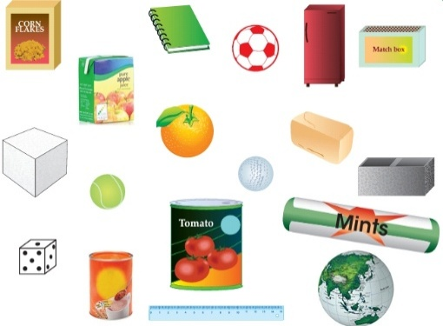 | Identifying solid shapes
Step 4  Development – Groups Activities and Presentation  (15 minutes) | Asks pupils –  Where can they be found (mention each item one by one)?  Home or School. | Cornflake – home  Book – home/school  Fridge – home, etc. | Identifying solid shapes in our environment – home or school
Step 5  Development  (5 minutes) | To conclude the lesson, the teacher revises the entire lesson and ask the key questions.  KEY QUESTIONS  Can you think of other items not in the picture but which can be found in your environment (at home or school)? What shapes are they? | The learners listen, ask and answer questions.  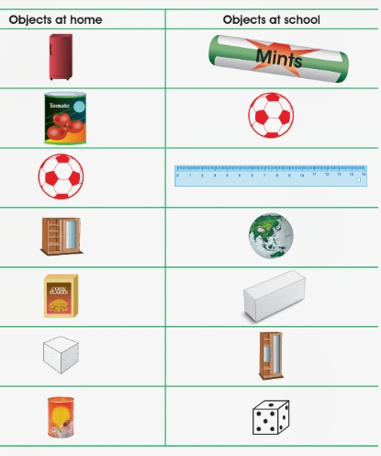 | Lesson Evaluation and Conclusion

Reference book – New Method Mathematics Book 1 2 3

Instructional Materials
