LESSON DEVELOPMENT ONE

SORTING THREE-DIMENSIONAL SHAPES

STAGE/TIME | TEACHER’S ACTIVITIES | LEARNER'S ACTIVITIES – MIND/HANDS ON | LEARNING POINTS
Step 1  Introduction – Introductory Activities  (5 minutes) | Guides pupils to identify the following objects. | 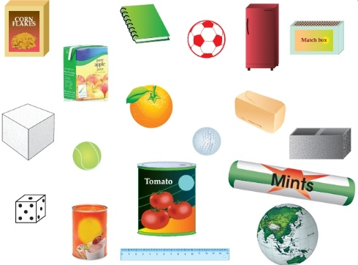  Cornflake, book, ball, fridge, sugar cube, baseball, bread, block etc. | Linking the Previous knowledge to the new lesson
Step 2  Development  (5 minutes)  Grouping | 1. Groups the learners into four groups – A, B, C, and D.  2. Guide the learners to choose a leader and secretary for your group.  3. Gives each group learning materials – samples/chart showing 3 dimensional shapes. | 1. Belong to a group.  2. Choose their leader and secretary.  3. Received learning materials for their group. | Learner’s group, leader and secretary confirmed.
Step 3  Development – Groups Activities  (10 minutes) | Guides the pupils to sort solid items gathered for this topic according to their similarity.  Allows them to mention the name of the items that belong to the same group. | 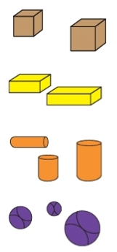 | Sorting three dimensional shapes
Step 4  Development – Groups Activities and Presentation  (15 minutes) | Guides pupils to –  Which objects look alike in each group? | 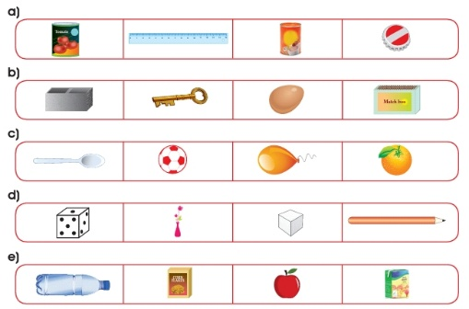 | Similar objects
Step 5  Development  (5 minutes) | To conclude the lesson, the teacher revises the entire lesson and ask the key questions. | The learners listen, ask and answer questions. | Lesson Evaluation and Conclusion

Reference book – New Method Mathematics Book 1 2 3

Instructional Materials
