LESSON DEVELOPMENT TWO

DESCRIPTION OF TWO DIMENSIONAL SHAPES

STAGE/TIME | TEACHER’S ACTIVITIES | LEARNER'S ACTIVITIES – MIND/HANDS ON | LEARNING POINTS
Step 1  Introduction – Introductory Activities  (5 minutes) | Asks pupils to identify the objects drawn below as square, rectangle, circle and triangle. |  | Linking the Previous knowledge to the new lesson
Step 2  Development  (5 minutes)  Grouping | 1. Groups the learners into four groups – A, B, C, and D.  2. Guide the learners to choose a leader and secretary for your group.  3. Gives each group learning materials – cut different two dimensional shapes. Chart of two dimensional shapes. | 1. Belong to a group.  2. Choose their leader and secretary.  3. Received learning materials for their group. | Learner’s group, leader and secretary confirmed.
Step 3  Development – Groups Activities  (20 minutes) | Guides pupils to describe triangle, square, rectangle and circle by identifying the sides or edges of the two dimensional shapes. | 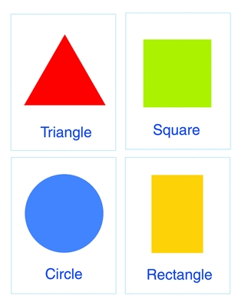 | Description of two dimensional shapes
Step 4  Development – Groups Activities and Presentation  (5 minutes) | Triangle  It has three sides.  Rectangle  It has 4 sidesIt has 2 equal long sides and 2 equal short sides. | Square  It has 4 sides. All the four sides are equal in length.  Circle  It is round. It has no straight sides | Properties of two dimensional shapes
Step 5  Development  (5 minutes) | To conclude the lesson, the teacher revises the entire lesson and ask the key questions.  KEY QUESTIONS  Name each of the following shapes. | The learners listen, ask and answer questions.  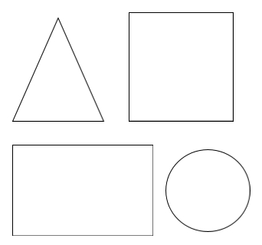 | Lesson Evaluation and Conclusion

Reference materials – New Method Mathematics Book 1 2 3

Instructional Materials

