LESSON DEVELOPMENT FOUR

CORNERS IN OTHER TWO DIMENSIONAL SHAPES

STAGE/TIME | TEACHER’S ACTIVITIES | LEARNER'S ACTIVITIES – MIND/HANDS ON | LEARNING POINTS
Step 1  Introduction – Introductory Activities  (5 minutes) | Look the chart carefully.  Asks pupils to mention the number of squares corners for each of the following shapes. | 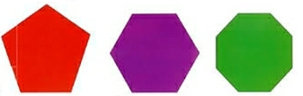 | Linking the Previous knowledge to the new lesson
Step 2  Development  (5 minutes)  Grouping | 1. Groups the learners into four groups – A, B, C, and D.  2. Guide the learners to choose a leader and secretary for your group.  3. Gives each group learning materials – chart showing other two dimensional shapes | 1. Belong to a group.  2. Choose their leader and secretary.  3. Received learning materials for their group. | Learner’s group, leader and secretary confirmed.
Step 3  Development – Groups Activities  (10 minutes) | Asks pupils – what letter is this?  Leads the pupils to identify, count and mention the number of corners in this shapes. | 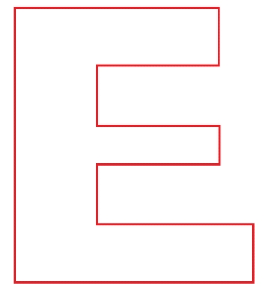 | Corners in other two dimensional shapes
Step 4  Development – Groups Activities and Presentation  (15 minutes) | Leads the pupils to identify, count and mention the number of corners in this shapes. |  | Leads the pupils to identify, count and mention the number of corners in this shapes.
Step 5  Development  (5 minutes) | To conclude the lesson, the teacher revises the entire lesson and ask the key questions.  SUMMARY  A corner is where two sides or edges meet. A corner may be square or not.  KEY QUESTIONS  How many square corners does each of the following shapes have? | The learners listen, ask and answer questions. | Lesson Evaluation and Conclusion

Reference materials – New Method Mathematics Book 1 2 3

Instructional Materials

