LESSON DEVELOPMENT THREE

SQUARE CORNERS IN TWO DIMENSIONAL SHAPES

STAGE/TIME | TEACHER’S ACTIVITIES | LEARNER'S ACTIVITIES – MIND/HANDS ON | LEARNING POINTS
Step 1  Introduction – Introductory Activities  (5 minutes) | Study the chart carefully. Guides and lets pupils to recognize and identify the of two dimensional shape. | 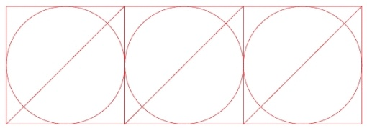  Triangle  Square  Rectangle, and  Circle. | Linking the Previous knowledge to the new lesson
Step 2  Development  (5 minutes)  Grouping | 1. Groups the learners into four groups – A, B, C, and D.  2. Guide the learners to choose a leader and secretary for your group.  3. Gives each group learning materials – chart showing patterns of two dimensional shapes and cut – out of two dimensional shapes. 11 Straws | 1. Belong to a group.  2. Choose their leader and secretary.  3. Received learning materials for their group. | Learner’s group, leader and secretary confirmed.
Step 3  Development – Groups Activities  (10 minutes) | Asks pupils to complete the statements given below using the pattern drawn.  1. There are _____ rectangles in the pattern  2. There are _____ squares in the pattern. | 3. There are _____ circles in the pattern.  4. There are _____ triangles in the pattern. | Patterns and two dimensional shapes
Step 4  Development – Groups Activities and Presentation  (15 minutes) | Arranges 3 straws to a triangle and rectangle (or square) and asks the pupils to identify the shapes.  Leads the pupils to identify square corners from cut - outs of rectangles, squares and triangles. | 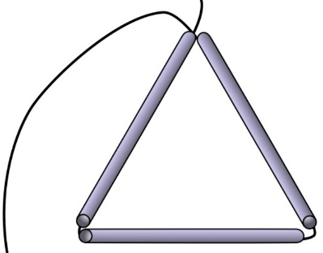  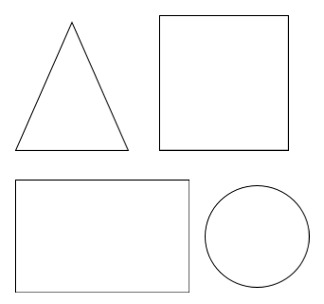 | Identifying number of corners and sides of two dimensional shapes
Step 5  Development  (5 minutes) | To conclude the lesson, the teacher revises the entire lesson and ask the key questions.  SUMMARY  A corner is where two sides or edges meet. A corner may be square or not.  KEY QUESTIONS  How many square corners does each of the following shapes have? | The learners listen, ask and answer questions.  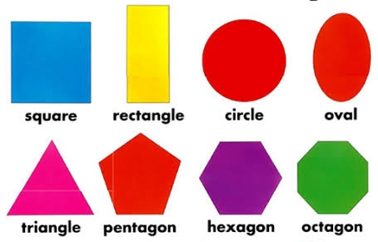 | Lesson Evaluation and Conclusion

Reference materials – New Method Mathematics Book 1 2 3

Instructional Materials
