LESSON DEVELOPMENT ONE

IDENTIFICATION OF TWO DIMENSIONAL SHAPES

STAGE/TIME | TEACHER’S ACTIVITIES | LEARNER'S ACTIVITIES – MIND/HANDS ON | LEARNING POINTS
Step 1  Introduction – Introductory Activities  (5 minutes) | Match the face of the objects in the left column with their flat surfaces on the right. | 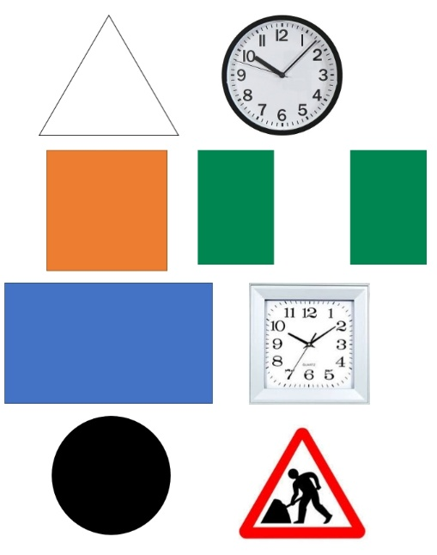 | Linking the Previous knowledge to the new lesson
Step 2  Development  (5 minutes)  Grouping | 1. Groups the learners into four groups – A, B, C, and D.  2. Guide the learners to choose a leader and secretary for your group.  3. Gives each group learning materials – samples/chart showing two dimensional shapes. Mathematical sets. | 1. Belong to a group.  2. Choose their leader and secretary.  3. Received learning materials for their group. | Learner’s group, leader and secretary confirmed.
Step 3  Development – Groups Activities  (10 minutes) | Guides pupils to draw triangle, square, rectangle and circle with appropriate drawing tools (pencil, ruler and a round object for a circle). | 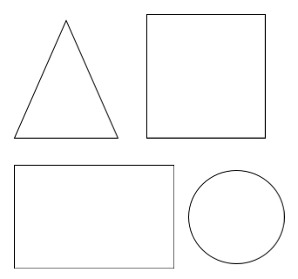 | Drawing two dimensional shapes
Step 4  Development – Groups Activities and Presentation  (15 minutes) | Guides pupils to identify two dimensional shapes with names and asks them to describe each of two dimensional shapes. | 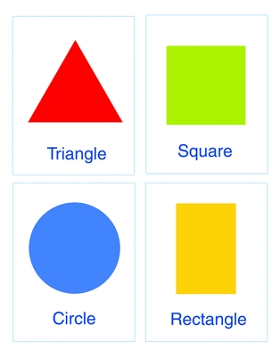 | Identification of two dimensional shapes – triangle, square, rectangle and circle.  Description of each shape.
Step 5  Development  (5 minutes) | To conclude the lesson, the teacher revises the entire lesson and ask the key questions.  KEY QUESTIONS  Match these two-dimensional shapes with their names. | The learners listen, ask and answer questions.  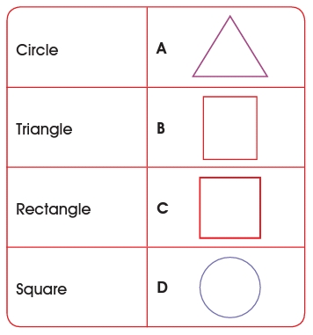 | Lesson Evaluation and Conclusion

Reference materials – New Method Mathematics Book 1 2 3

Instructional Materials

