LESSON DEVELOPMENT THREE

LINE (S) OF LINE (S) OF SYMMETRY – RECTANGLE AND CIRCLE

STAGE/TIME | TEACHER’S ACTIVITIES | LEARNER'S ACTIVITIES – MIND/HANDS ON | LEARNING POINTS
Step 1  Introduction – Introductory Activities  (5 minutes) | 1. _________ is a line(s) that divide into equal and similar parts.  (a) line of symmetry (b) straight line (c) curve line  2. Triangle has _________ lines of symmetry.  (a) 2 (b) 3 (c) 4  3. Square has _________ lines of symmetry.  (a) 2 (b) 3 (c) 4  4. Line(s) of symmetry is one of the properties of a triangle and square. True or False | 1. (a)  2. (b)  3. (4)  4. True | Linking the Previous knowledge to the new lesson
Step 2  Development  (5 minutes)  Grouping | 1. Groups the learners into four groups – A, B, C, and D.  2. Guide the learners to choose a leader and secretary for your group.  3. Gives each group learning materials – cut – out the shapes of rectangle and circle. Chart showing triangle and square. | 1. Belong to a group.  2. Choose their leader and secretary.  3. Received learning materials for their group. | Learner’s group, leader and secretary confirmed.
Step 3  Development – Groups Activities  (10 minutes) | Guides the pupils to fold rectangle into equal and similar parts.  Brings out the square folded in the previous lesson.  Guides them to prove why square has 4 lines of symmetry and rectangle has 2 lines of symmetry. | 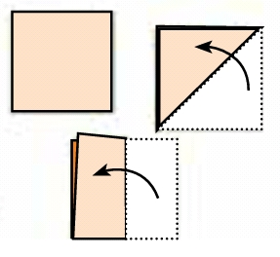  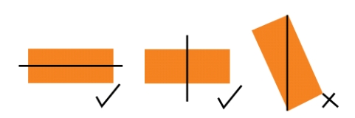  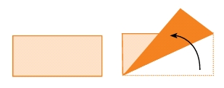 | Lines of symmetry in rectangle and square
Step 4  Development – Groups Activities and Presentation  (10 minutes) | Guides pupils to fold (as many times possible) a circle into equal and similar parts.  As they fold, asks them to trace each line with pencil and ruler.  Asks them how many lines of symmetry in a rectangle and circle. | 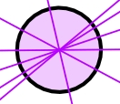  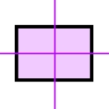  A circle has uncountable lines of symmetry while rectangle and 2 lines of symmetry. | Line(s) of symmetry
Step 5  Development  (10 minutes) | To conclude the lesson, the teacher revises the entire lesson and ask the key questions.  SUMMARY  You can find if a shape has a Line of Symmetry by folding it.  When the folded part sits perfectly on top (all edges matching), then the fold line is a Line of Symmetry.  Line(s) of symmetry is one of the properties of a triangle and square. | The learners listen, ask and answer questions.  KEY QUESTIONS  1. Rectangle and square have the same number of symmetry. True or False  2. Triangle has _________ lines of symmetry.  (a) 2 (b) 3 (c) 4  3. Circle has _________ lines of symmetry.  (a) 2 (b) 3 (c) 4  4. Draw the lines of symmetry on the following shapes.  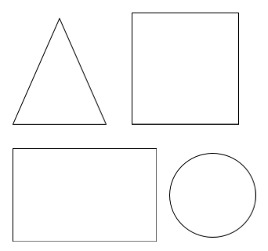 | Lesson Evaluation and Conclusion

Reference materials – New Method Mathematics Book 1 2 3

Instructional Materials

