LESSON DEVELOPMENT TWO

LINE (S) OF LINE (S) OF SYMMETRY – TRIANGLE AND SQUARE

STAGE/TIME | TEACHER’S ACTIVITIES | LEARNER'S ACTIVITIES – MIND/HANDS ON | LEARNING POINTS
Step 1  Introduction – Introductory Activities  (5 minutes) | Guides the pupils to identify each of the letters on the chart.  Asks them if they see a dotted line(s) on each of the letter. If yes, how many dotted line(s) each of the letters. | 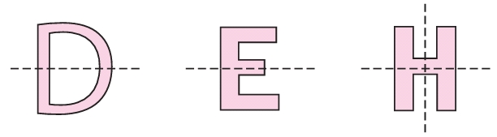  Letter D, E and H. Letter D has 1 dotted line. Letter E has one dotted line while letter H has two dotted lines. | Linking the Previous knowledge to the new lesson
Step 2  Development  (5 minutes)  Grouping | 1. Groups the learners into four groups – A, B, C, and D.  2. Guide the learners to choose a leader and secretary for your group.  3. Gives each group learning materials – cut – out the shapes of triangle (equilateral) and square. Chart showing triangle and square. | 1. Belong to a group.  2. Choose their leader and secretary.  3. Received learning materials for their group. | Learner’s group, leader and secretary confirmed.
Step 3  Development – Groups Activities  (5 minutes) | Asks the pupils to trace the dotted line(s) with a pencil using ruler.  Guides them to fold each letter equally.  Asks them, what is their observations.  Tells the pupils, the line is called line(s) of symmetry. | The line(s) divides the letter into equal and similar parts. | Drawing and folding alphabets – D, E and H.
Step 4  Development – Groups Activities and Presentation  (20 minutes) | Guides them to fold the triangle and the square in all possible ways.  Lets them to trace and count the number of lines made by folding. | 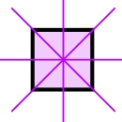  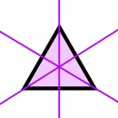  There are 3 lines on the triangle and 4 on the square. | Line(s) of symmetry
Step 5  Development  (5 minutes) | To conclude the lesson, the teacher revises the entire lesson and ask the key questions.  SUMMARY  You can find if a shape has a Line of Symmetry by folding it.  When the folded part sits perfectly on top (all edges matching), then the fold line is a Line of Symmetry.  Line(s) of symmetry is one of the properties of a triangle and square. | The learners listen, ask and answer questions.  KEY QUESTIONS  1. _________ is a line(s) that divide into equal and similar parts.  (a) line of symmetry  (b) straight line  (c) curve line  2. Triangle has _________ lines of symmetry.  (a) 2  (b) 3  (c) 4  3. Square has _________ lines of symmetry.  (a) 2  (b) 3  (c) 4  4. Line(s) of symmetry is one of the properties of a triangle and square. True or False | Lesson Evaluation and Conclusion

Reference materials – New Method Mathematics Book 1 2 3

Instructional Materials

