LESSON DEVELOPMENT ONE

PROPERTIES OF TRIANGLE, SQUARE, RECTANGLE AND CIRCLE

STAGE/TIME | TEACHER’S ACTIVITIES | LEARNER'S ACTIVITIES – MIND/HANDS ON | LEARNING POINTS
Step 1  Introduction – Introductory Activities  (5 minutes) | Asks the pupils to identify each the following shapes by name. | 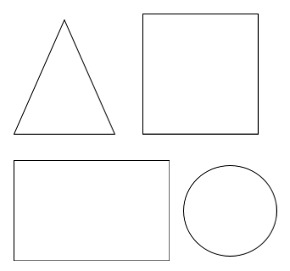  Triangle, square, rectangle and circle. | Linking the Previous knowledge to the new lesson
Step 2  Development  (5 minutes)  Grouping | 1. Groups the learners into four groups – A, B, C, and D.  2. Guide the learners to choose a leader and secretary for your group.  3. Gives each group learning materials – cut – out the shapes of triangle, square, rectangle and circle. Chart showing triangle, square, rectangle and circle with corresponding real objects. | 1. Belong to a group.  2. Choose their leader and secretary.  3. Received learning materials for their group. | Learner’s group, leader and secretary confirmed.
Step 3  Development – Groups Activities  (5 minutes) | Asks pupils to match the face of the objects in the left column with their flat surfaces on the right. | 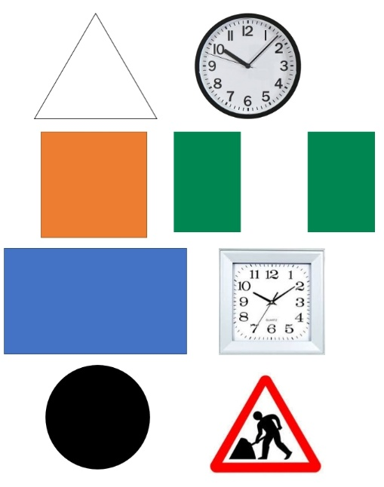 | Two dimensional shapes with corresponding objects.
Step 4  Development – Groups Activities and Presentation  (20 minutes) | Guides pupils to describe triangle, square, rectangle and circle by identifying the sides or edges and corners of each of the shape.  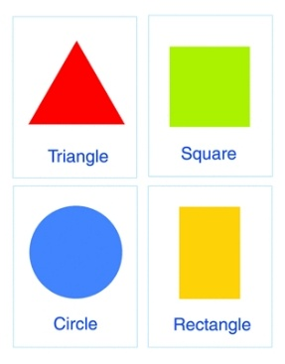  Circle  1. It is round.  2. It has no straight sides.  3. It has no corners. | Triangle  1. It has three sides.  2. It has 3 corners.  Rectangle  1. It has 4 sides.  2. It has 2 equal long sides and 2 equal short sides.  3. It has 4 corners.  Square  1. It has 4 sides.  2. All the four sides are equal in length.  3. It has 4 corners. | Properties of Triangle, Square, Rectangle and Circle
Step 5  Development  (5 minutes) | To conclude the lesson, the teacher revises the entire lesson and ask the key questions.  KEY QUESTIONS  Cut out and colour your shapes using their favourite colours. | The learners listen, ask and answer questions. | Lesson Evaluation and Conclusion

Reference materials – New Method Mathematics Book 1 2 3

Instructional Materials

