TYPES OF THERMOMETER
There are different types of thermometer –
1. Clinical thermometer
2. Minimum and maximum thermometer.
3. Gas thermometer
4. Liquid in glass thermometer
5. Infrared thermometer
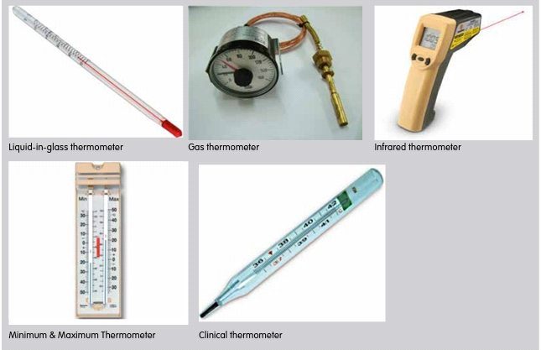

USES OF THERMOMETER
1. To measure the outdoor temperature.
2. To measure body temperature during a physical exam at the doctor’s.
3. To measure body temperature when someone is ill to determine if he/she has a fever.
4. To measure the temperature of an oven.
6. To measure the temperature of a pool.

