LESSON DEVELOPMENT ONE

UNITS AND SYMBOLS OF TEMPERATURE SCALE

STAGE/TIME | TEACHER’S ACTIVITIES | LEARNER'S ACTIVITIES – MIND/HANDS ON | LEARNING POINTS
Step 1  Introduction – Introductory Activities  (5 minutes) | Shows a thermometer to the pupils. Also show a big labelled diagram of one.  Tells them that the number on the thermometer is its scale. While the letter °C and °F are units (symbols) of temperature. | 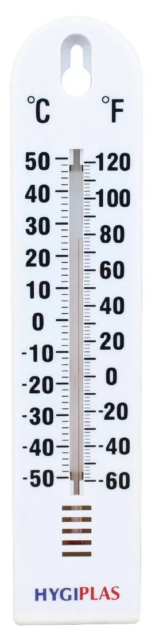 | Linking the Previous knowledge to the new lesson
Step 2  Development  (5 minutes)  Grouping | 1. Groups the learners into four groups – A, B, C, and D.  2. Guide the learners to choose a leader and secretary for your group.  3. Gives each group learning materials – sample/chart showing thermometer. | 1. Belong to a group.  2. Choose their leader and secretary.  3. Received learning materials for their group. | Learner’s group, leader and secretary confirmed.
Step 3  Development – Groups Activities  (10 minutes) | Tells the pupils that the °C and °F stand for degree Celsius (or Centigrade) and degree Fahrenheit.  Ask them to look at chart carefully.  0° C is the freezing point of water. Its equivalent is 32°F. 100°C is the boiling point. Its equivalent is 213°. | 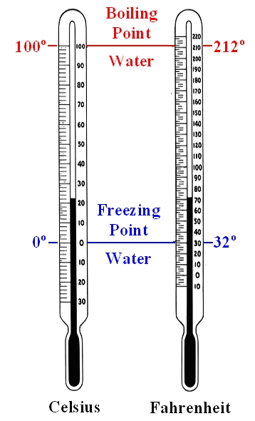 | Instructions used for measuring thermometer
Step 4  Development – Groups Activities  (10 minutes) | What is the equivalent of  1. 10° C°  2. 70° C,  3. 10° F  4. 70° F. |  | High and low temperature.  Meaning of thermometer.
Step 5  Development  (10 minutes) | Asks each group to present their results/solutions so that you can compare responses with those in other groups. | Presentation | Group Presentation
Step 6  Conclusion  (5 minutes) | To conclude the lesson, the teacher revises the entire lesson and ask the key questions.  SUMMARY  Temperature is the degree of hotness or coldness of an object. To measure how hot or cold an object is, we use a thermometer. | The learners listen, ask and answer questions.  KEY QUESTIONS  What is the different between temperature and thermometer? | Lesson Evaluation and Conclusion

Reference book – Primary 5 Basic Science & Technology

