LESSON DEVELOPMENT TWO

TYPES OF BUILDING

STAGE/TIME | TEACHER’S ACTIVITIES | LEARNER'S ACTIVITIES – MIND/HANDS ON | LEARNING POINTS
Step 1  Introduction – Introductory Activities  (5 minutes) | Asks pupils to describe each stage of the following building.  Asks them to mention materials needed to complete these buildings. | 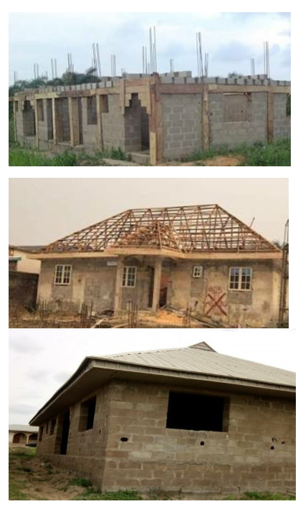 | Linking the Previous knowledge to the new lesson
Step 2  Development  (5 minutes)  Grouping | 1. Groups the learners into four groups – A, B, C, and D.  2. Guide the learners to choose a leader and secretary for your group.  3. Gives each group learning materials – sample/chart showing materials needed for building. | 1. Belong to a group.  2. Choose their leader and secretary.  3. Received learning materials for their group. | Learner’s group, leader and secretary confirmed.
Step 3  Development – Groups Activities  (10 minutes) | Asks the pupils to identify the following building materials.  Lets them to summarize the uses of these materials in one sentence.  Asks them to mention other building materials. | 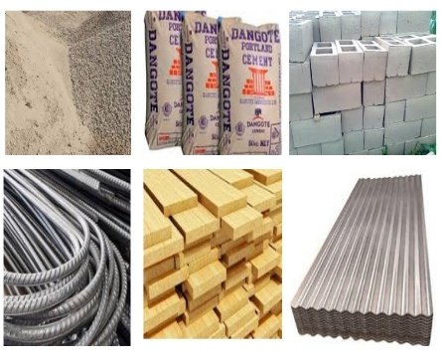  Sand, cements, blocks, irons, planks and roofing sheet. | Materials needed for building
Step 4  Development – Groups Activities and Presentation  (15 minutes) | Asks each group to present their results/solutions so that you can compare responses with those in other groups. | Presentation | Other building materials
Step 5  Development  (5 minutes) | To conclude the lesson, the teacher revises the entire lesson and ask the key questions.  SUMMARY  A building is a place with walls and a roof.  There are many types of buildings, such as bungalows, detached buildings, duplexes, semi-detached buildings, high-rise buildings, schools, churches and mosques.  There are many materials used for putting up a building, some of which are bricks, sand, gravel, wood, iron rods, glass, pipes, etc. | The learners listen, ask and answer questions.  KEY QUESTIONS  1. Describe what a building is.  2. Name five materials which are used for setting up buildings. Explain the functions of the materials.  3.Name five types of buildings. Draw a sketch of each type. What can each type be used for? | Lesson Evaluation and Conclusion

Instructional Materials

