LESSON DEVELOPMENT ONE

MEANING OF BUILDINGS

STAGE/TIME | TEACHER’S ACTIVITIES | LEARNER'S ACTIVITIES – MIND/HANDS ON | LEARNING POINTS
Step 1  Introduction – Introductory Activities  (10 minutes) | Takes the pupils to the streets around the school.  Asks them to point to every building they see.  Lets them that house is also known as a building. | 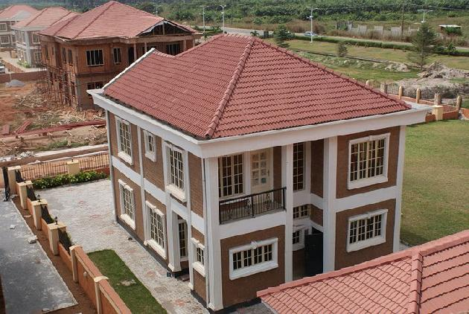 | Linking the Previous knowledge to the new lesson
Step 2  Development  (5 minutes)  Grouping | 1. Groups the learners into four groups – A, B, C, and D.  2. Guide the learners to choose a leader and secretary for your group.  3. Gives each group learning materials – drawing materials. | 1. Belong to a group.  2. Choose their leader and secretary.  3. Received learning materials for their group. | Learner’s group, leader and secretary confirmed.
Step 3  Development – Groups Activities  (10 minutes) | Asks each of pupil in the group to draw two different building.  Lets them compare the building drawn in their group and describe the building. |  | Drawing and describing building
Step 4  Development – Groups Activities and Presentation  (10 minutes) | Asks each group to present their results/solutions so that you can compare responses with those in other groups. | Presentation | Meaning of building
Step 5  Development  (10 minutes) | To conclude the lesson, the teacher revises the entire lesson and ask the key questions.  SUMMARY  A building is a place which has walls and a roof. People can live in it, work in it and do other things (e.g. worship) in it. | The learners listen, ask and answer questions.  KEY QUESTIONS  Find out different types of building in your street and describe them with drawing. | Lesson Evaluation and Conclusion

Instructional Materials

