LESSON DEVELOPMENT TWO

TYPES OF BUILDING

STAGE/TIME | TEACHER’S ACTIVITIES | LEARNER'S ACTIVITIES – MIND/HANDS ON | LEARNING POINTS
Step 1  Introduction – Introductory Activities  (5 minutes) | Asks the pupils to look at different types of building showing the chart.  Asks them if they have see any similar building with the ones on chart. | 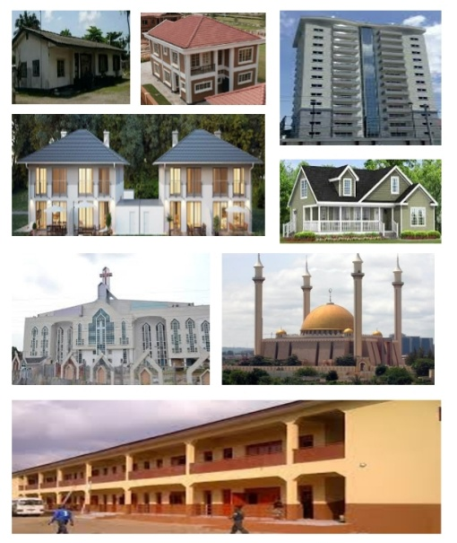 | Linking the Previous knowledge to the new lesson
Step 2  Development  (5 minutes)  Grouping | 1. Groups the learners into four groups – A, B, C, and D.  2. Guide the learners to choose a leader and secretary for your group.  3. Gives each group learning materials – chart showing different types of building | 1. Belong to a group.  2. Choose their leader and secretary.  3. Received learning materials for their group. | Learner’s group, leader and secretary confirmed.
Step 3  Development – Groups Activities  (5 minutes) | Lets them identify and describe each of the building. |  | Types of building
Step 4  Development – Groups Activities and Presentation  (15 minutes) | Asks each group to present their results/solutions so that you can compare responses with those in other groups. | Presentation  A bungalow, duplex, story (one, two,...) building, detached building, school building, church and mosque building, etc. | Types of building
Step 5  Development  (10 minutes) | To conclude the lesson, the teacher revises the entire lesson and ask the key questions.  SUMMARY  There are many types of buildings, such as bungalows, detached buildings, duplexes, semi-detached buildings, high-rise buildings, schools, churches and mosques. | The learners listen, ask and answer questions.  KEY QUESTIONS  What are the different between one and two storey buildings. | Lesson Evaluation and Conclusion

Instructional Materials
