LESSON DEVELOPMENT TWO

OPEN AND CLOSED SHAPES

STAGE/TIME | TEACHER’S ACTIVITIES | LEARNER'S ACTIVITIES – MIND/HANDS ON | LEARNING POINTS
Step 1  Introduction – Introductory Activities  (5 minutes) | Asks the pupils to identify the names of the following items according to the ground they belong – cube, cuboid, cylinder and sphere | 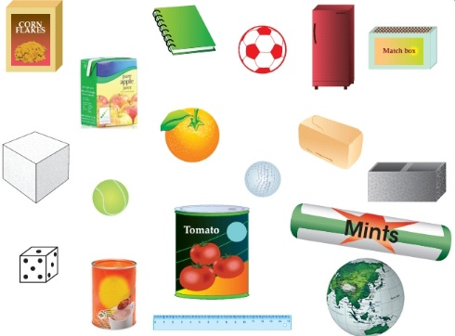 | Linking the Previous knowledge to the new lesson
Step 2  Development  (5 minutes)  Grouping | 1. Groups the learners into four groups – A, B, C, and D.  2. Guide the learners to choose a leader and secretary for your group.  3. Gives each group learning materials – real objects (milo tin with and without cover, 2 cartoons each for cube and cuboid that can be covered and can’t be covered. | 1. Belong to a group.  2. Choose their leader and secretary.  3. Received learning materials for their group. | Learner’s group, leader and secretary confirmed.
Step 3  Development – Groups Activities  (10 minutes) | Asks them to study each of the two similar solid objects, compare and state their difference. | 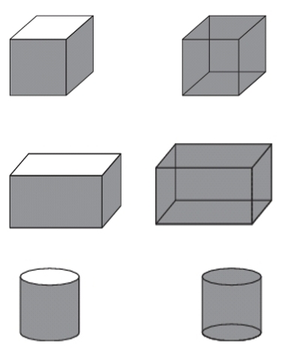 | Open and closed shapes
Step 4  Development – Groups Activities and Presentation  (15 minutes) | Presentation | 1. Open object do not have a cover at the top. The inside of an open object can be seen, because it has no cover or top face.  2. The inside of a close object cannot be seen because of the cover or top face. | Groups Presentation
Step 5  Development  (5 minutes) | To conclude the lesson, the teacher revises the entire lesson and ask the key questions. | The learners listen, ask and answer questions.  KEY QUESTIONS  Give 5 examples each for solid open and closed shapes in their environment. | Lesson Evaluation and Conclusion

Reference book – New Method Mathematics Book 1

Instructional Materials

