LESSON DEVELOPMENT THREE

PROPERTIES OF CUBE AND CUBOID

STAGE/TIME | TEACHER’S ACTIVITIES | LEARNER'S ACTIVITIES – MIND/HANDS ON | LEARNING POINTS
Step 1  Introduction – Introductory Activities  (5 minutes) | Asks pupils to identify cube and cuboid among the following three dimensional shapes. | 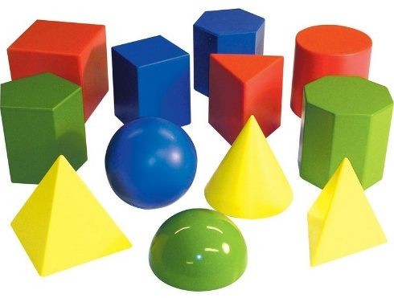 | Linking the Previous knowledge to the new lesson
Step 2  Development  (5 minutes)  Grouping | 1. Groups the learners into four groups – A, B, C, and D.  2. Guide the learners to choose a leader and secretary for your group.  3. Gives each group learning materials – open and closed cube and cuboid | 1. Belong to a group.  2. Choose their leader and secretary.  3. Received learning materials for their group. | Learner’s group, leader and secretary confirmed.
Step 3  Development – Groups Activities  (10 minutes) | Guides pupils to identify the edge, face and vertex of cube and cuboid.  Asks the groups to –  Find the total number of edges, faces and vertice (corners).  State the similarities and different between their properties. | 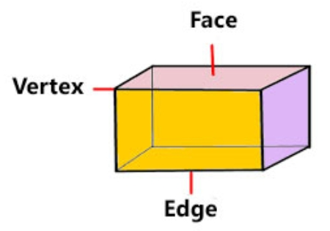 | Properties of cube and cuboid
Step 4  Development – Groups Activities and Presentation  (15 minutes) | Presentation | SIMILARITIES – Both have equal number of edges, faces and vertice.  DIFFERENT –  Cube  A cube has 8 vertices  A cube has 12 equal edges  A cube has 6 equal faces  Cuboid  A cuboid has 8 vertices  A cuboid has 12 unequal edges  A cuboid has 6 unequal faces | Groups Presentation
Step 5  Development  (5 minutes) | To conclude the lesson, the teacher revises the entire lesson and ask the key questions.  KEY QUESTIONS  Copy and complete the following.  1. A three-dimensional shape having equal faces _______. | The learners listen, ask and answer questions.  2. A cuboid has _______ unequal faces.  3. The face of a cuboid is a _______.  4. An open shoe box has _____________ faces. | Lesson Evaluation and Conclusion

Reference book – New Method Mathematics Book

Instructional Materials

