LESSON DEVELOPMENT FOUR

PROPERTIES OF CYLINDER AND SPHERE

STAGE/TIME | TEACHER’S ACTIVITIES | LEARNER'S ACTIVITIES – MIND/HANDS ON | LEARNING POINTS
Step 1  Introduction – Introductory Activities  (5 minutes) | Asks pupils to identify cylinder and sphere among the following three dimensional shapes. | 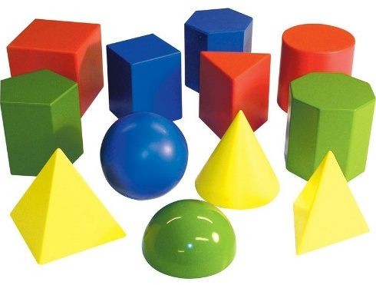 | Linking the Previous knowledge to the new lesson
Step 2  Development  (5 minutes)  Grouping | 1. Groups the learners into four groups – A, B, C, and D.  2. Guide the learners to choose a leader and secretary for your group.  3. Gives each group learning materials – open and closed cylinder and sphere. | 1. Belong to a group.  2. Choose their leader and secretary.  3. Received learning materials for their group. | Learner’s group, leader and secretary confirmed.
Step 3  Development – Groups Activities  (10 minutes) | Guides pupils to identify the edge, face and vertex of cube and cuboid.  Asks the groups to –  Find the total number of edges, faces and vertice (corners).  State the similarities and different between their properties. | 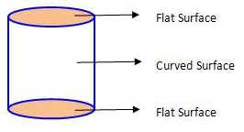  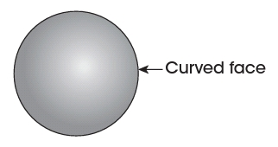 | Properties of cylinder and sphere
Step 4  Development – Groups Activities and Presentation  (15 minutes) | Presentation | SIMILARITIES – Both has curved face.  DIFFERENT  Cylinder  1. A cylinder has one curved face.  2. It has two flat faces It has no vertex  Sphere  1. A sphere has one curved face only.  2. It has no edge and no vertex. | Groups Presentation
Step 5  Development  (5 minutes) | To conclude the lesson, the teacher revises the entire lesson and ask the key questions.  KEY QUESTIONS  Copy and complete the following.  1. A cylinder has ______ flat circular faces. | The learners listen, ask and answer questions.  2. A cone has ______ edge.  3. An open shoe box has ______ faces. | Lesson Evaluation and Conclusion

Reference book – New Method Mathematics Book

Instructional Materials

