LESSON DEVELOPMENT ONE

COMPARING AREA OF OBJECTS AND SHAPES

STAGE/TIME | TEACHER’S ACTIVITIES | LEARNER'S ACTIVITIES – MIND/HANDS ON | LEARNING POINTS
Step 1  Introduction – Introductory Activities  (5 minutes) | Asks pupils – what shape is this?  Guides them to compare the two shapes together by placing each other shape on the other. Then ask, what is the different between both shapes. |  | Linking the Previous knowledge to the new lesson
Step 2  Development  (5 minutes)  Grouping | 1. Groups the learners into four groups – A, B, C, and D.  2. Guide the learners to choose a leader and secretary for your group.  3. Gives each group learning materials – cut out shapes of different sizes – triangle, square, rectangle and circle. | 1. Belong to a group.  2. Choose their leader and secretary.  3. Received learning materials for their group. | Learner’s group, leader and secretary confirmed.
Step 3  Development – Groups Activities  (10 minutes) | Asks pupils to compare the following circles with one another.  While the pupils are comparing, guides them to use the word ‘area’ to state the difference. | B  A  C | Comparing the area of different sizes of a circle.
Step 4  Development – Groups Activities and Presentation  ( 15 minutes) | Guides the pupils to compare the areas of the following shapes.  Note – the shapes must be cut not on chart. | 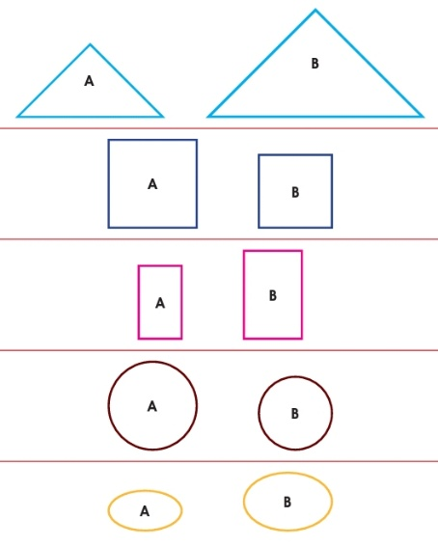 | Comparing areas different shapes – triangles, squares, rectangles and circles
Step 5  Development  (5 minutes) | To conclude the lesson, the teacher revises the entire lesson and ask the key questions. | The learners listen, ask and answer questions. | Lesson Evaluation and Conclusion

Reference book – New Method Mathematics Book 1 2 3

