LESSON DEVELOPMENT FOUR

TEST
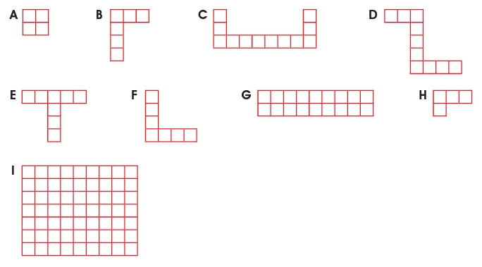
Find the areas of the following shapes A – I.

