LESSON DEVELOPMENT ONE

SORTING TWO - DIMENSIONAL SHAPES

STAGE/TIME | TEACHER’S ACTIVITIES | LEARNER'S ACTIVITIES – MIND/HANDS ON | LEARNING POINTS
Step 1  Introduction – Introductory Activities  (5 minutes) | Guides the pupils to sort the shapes according to same colour.  Asks them – How many of the shapes are each colour? | 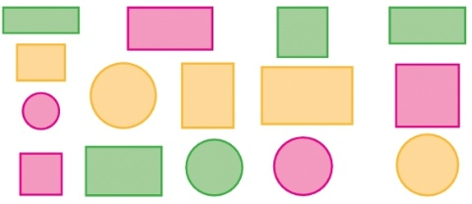  Green – 5  Pink – 5  Orange – 5 | Linking the Previous knowledge to the new lesson
Step 2  Development  (5 minutes)  Grouping | 1. Groups the learners into four groups – A, B, C, and D.  2. Guide the learners to choose a leader and secretary for your group.  3. Gives each group learning materials – cut shapes of square, rectangle and circle. 5 each. | 1. Belong to a group.  2. Choose their leader and secretary.  3. Received learning materials for their group. | Learner’s group, leader and secretary confirmed.
Step 3  Development – Groups Activities  (10 minutes) | Guides the pupils to sort the shapes according to how they look alike.  Ensures that shapes having the different colours are provided for pupils for demonstration.  Lets the shapes be packed in a box. | 3 shapes look like this shape –  7 shapes look like this shape –  5 shapes look like this shape – | Sorting two dimensional shapes
Step 4  Development – Groups Activities and Presentation  (10 minutes) | Guides pupils –  Identify the shapes that are alike on the boxes chart. | 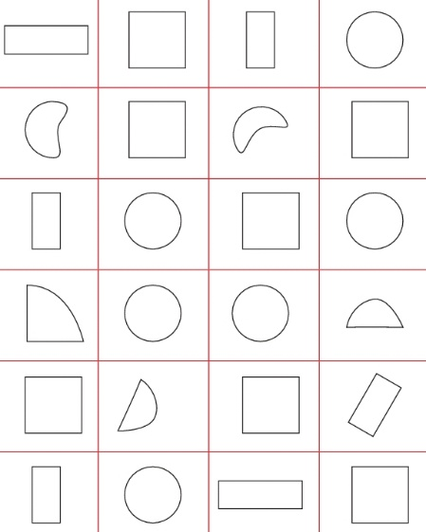 | Similar objects
Step 5  Development  (10 minutes) | To conclude the lesson, the teacher revises the entire lesson and ask the key questions. | The learners listen, ask and answer questions. | Lesson Evaluation and Conclusion

Reference book – New Method Mathematics Book 1 2 3

Instructional Materials

